Communique'

President - Scott Lane 599-7240 Vice President – Al(den) Johnson, O.D.   
Secretary – Clarence Johnson Treasurer – Carl Williams, M.D.   
[website – [www.sabbsa.org](http://www.sabbsa.org) ] [P.O. Box 34478, San Antonio, TX 78265]

**February 2017**

Greetings from the San Antonio Bible Based Sciences Association (SABBSA)! As we write this we are getting a new roof put on the house and replacing window screens and other parts of our house damaged by the hail and wind storms we experienced in the San Antonio area this past spring. We pray many of you are having happier times, but we thank God for His help in rebuilding.

This **Communique newsletter** touches on a wide range of subjects. The first article exposes how NASA rover data is being used to push an evolutionary agenda, when the data could lead to many other conclusions. Another article shows how little we really understand about the human body and how wonderfully made our Incredibly Brilliant Creator is! Yet another article explores how bad the data is on the age of our moon. Our last article details the news of our state school board’s efforts in holding the line of good scientific inquiry in our public schools against staunch opposition.

A special article in this newsletter is timely in view of next month’s monthly SABBSA presentation on climate change by SABBSA Vice President Dr. Al Johnson. The 3rd Congress of Freedom Force

was convened in Phoenix, Arizona, on December 3 & 4, 2016. The theme of the Congress was …

**Global-Warming; an Inconvenient Lie**. We will inform you of the keynote speakers at that conference and their topics as well as show you how to get a copy of this informative conference.

As always, we have a full rundown of all of the creation education events happening in the greater San Antonio area in the coming months. As always, we have a full rundown of all the creation education events happening in the greater San Antonio area in the coming months in this Newsletter and on our website, [www.sabbsa.org](http://www.sabbsa.org) .

Three things of special note this month:

1. A **Worldview Conference will be held at Faith Lutheran Church on Feb. 10-11**, details inside.

2. A major motion picture documentary, **“Is Genesis History?,”** will appear in theaters for one night only this month on February 23. Details on theater locations, getting tickets and show times as well as information about the movie are all available in this newsletter.

3. Answers in Genesis’ **Dr. Tommy Mitchell will be in town February 19-20 at Fellowship Bible Church**. Details below.

We pray you will find something in this newsletter which will edify you and help you in your walk with Christ and bolster your ability to evangelize.

**Did NASA Mars Rover find a signature of past life?**

Ecerpts from an article by Leonard David Space.com's Space Insider Columnist

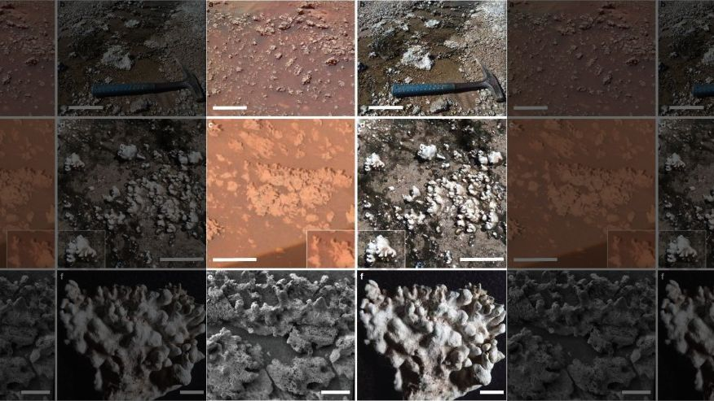

Home Plate opaline silica (left) occurs in nodular masses with digitate structures that resemble those at El Tatio (right).  (ASU/Ruff & Farmer)

During its wheeled treks on the Red Planet, NASA's Spirit rover may have encountered a potential signature of past life on Mars, report scientists at Arizona State University (ASU).

To help make their case, the researchers have contrasted the rover Spirit's study of "Home Plate" — a plateau of layered rocks that the robot explored during the early part of its third year on Mars — with features found within active hot spring/geyser discharge channels at a site in northern Chile called El Tatio.

The work has resulted in a provocative paper: "Silica deposits on Mars with features resembling hot spring biosignatures at El Tatio in Chile." …

"Although fully abiotic processes are not ruled out for the Martian silica structures, they satisfy an a priori definition of potential biosignatures," the researchers wrote in the study**…**

Spirit encountered outcrops and regolith composed of opaline silica (amorphous SiO2nH2O) in an ancient volcanic hydrothermal setting in Gusev crater.

An origin via either fumarole-related acid-sulfate leaching or precipitation from hot spring fluids was considered possible. "However, the potential significance of the characteristic nodular and [millimeter]-scale digitate opaline silica structures was not recognized," Ruff and Farmer noted in the new study…

Previously, a NASA science team defined a potential biosignature as "an object, substance and/or pattern that might have a biological origin and thus compels investigators to gather more data before reaching a conclusion as to the presence or absence of life."

"Because we can neither prove nor disprove a biological origin for the microstromatolite-like digitate silica structures at Home Plate, they constitute a potential biosignature according to this definition," Ruff and Farmer wrote…

 The ASU researchers suggested that a future and specially instrumented rover mission could perhaps provide a more definitive assessment of possible biogenicity of Home Plate silica structures.

"However, because of the challenges in obtaining unambiguous evidence in situ, coordinated microscopic and compositional analyses of samples returned to laboratories on Earth may be required to reach a robust conclusion as to the presence or absence of past Martian life in these rocks," Ruff and Farmer stated.

**Editor’s Note: Please note that the qualifying statements that these formations could have been formed abiotically (with natural geologic or climatic process and not life) are always paired with the suppositions that these formations COULD show life bio-signatures. Indeed, this is evidence again of how NASA, my childhood hero, has had their mission hijacked in an all-out effort to find life outside of earth, no matter how slim the data.**



**The** **3rd Congress of Freedom Force**

was convened in Phoenix, Arizona, on December 3 & 4, 2016. The theme of the Congress was …

***Global-Warming;  
an Inconvenient Lie.***

It was a gathering of the world’s top experts on this subject who completely demolished the myth  
of anthropogenic (man-caused) global-warming.  
 The entire proceedings soon will be broadcast on the Internet. If you would like to be informed of the date and time of this free broadcast, click [here](mailto:ge.griffin31@gmail.com) and leave your name and email address where we can send the information.

**Lord Monckton   
*Global Warming Is A Monstrous Hoax***

Christopher Walter Monckton, 3rd Viscount Monckton of Brenchley, UK, is known for his journalism, conservative political views, opposition to the EU, and especially for masterful debunking of global warming. In 2016, he was a national leader in rallying the British vote on behalf of BREXIT. Lord Monckton is a member of the Freedom Force Hall of Honor.

**Tim Ball**    
***Global Warming Is the Biggest Deception in History***

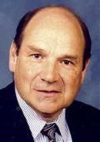Prof. Ball is a retired professor at the University of Winnipeg, Canada. He earned a Doctorate of Science at Queen Mary College, University of London, was Chairman of the Canadian Committee on Climatic Fluctuation, Chairman of Winnipeg’s Advisory Committee on Hazardous Waste, has authored 53 scientific papers, and is the author of *The Deliberate Corruption of Climate Science*. Professor Ball says that human-caused global warming is the biggest deception in history.

**Holly Swanson**  
**They Call It Education; Global Warming and Political Indoctrination**

Holly Swanson is the author of two books on the hidden agenda of the environmental movement. They are: *Set Up & Sold Out; Find Out What Green Really Means*, and *Training for Treason: The Harmful Agenda Behind Education for Sustainability.* She is the founder and director of We Choose Freedom, a citizen’s campaign to stop political indoctrination in our schools.

**Patrick Wood**  
***They Call it Science; Global Warming and Technocracy***

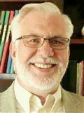Mr. Wood is the author of *Technocracy Rising; The Trojan Horse of Global Transformation*. He is the go-to source for information on the Trilateral Commission. He shows how the age-old drive for world power has morphed into new forms and now hides beneath phrases like environmentalism, the green economy, and sustainable development ‒ but, at its root, it remains an all-out attack on private property and financial independence.

**Debbie Bacigalupi  
*They Call It Smart Growth: Global Warming and The Depopulation of Rural America***

Miss Bacigalupi is a long-time student of the global-warming myth. She attended the UN’s Paris-21 Conference on Climate Change as an observer and critic. She will show how Agenda-21 will be used to place an unbearable yoke of taxation on developed countries. This is said to be for the benefit of poor nations, but most of it will go to politicians, bureaucrats, and military ‒ in the name of fighting global warming.

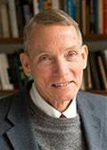**William Happer   
*The Real Inconvenient Truth; More CO2 Benefits the Earth***

Prof. Happer is a professor at Princeton University in the field of atomic physics, optics, and spectroscopy. He is a pioneer developer of adaptive optics. He has served as Director of Science in the US Department of Energy. Professor Happer is a strong voice against the myth of anthropogenic global warming and says there is no reason to believe that CO2 levels are a major factor in climate change.

**G. Edward Griffin**  
***Why Do They Deceive?***

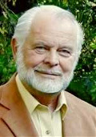Mr. Griffin is an author, film maker, and Founder of Freedom Force. His best-known works are *The Creature from Jekyll Island*and *World without Cancer*. He shows that the myth makers are driven by an ideology called collectivism, and that global warming is a tactic to frighten us into accepting total government (the essence of collectivism) as necessary to save the planet. Without this understanding, the myth makers may seem stupid but, with it, we see that they are very smart in pursuit of their agenda.

**Dan Happel**  
***They Call It Green; Global Warming and Agenda-21***

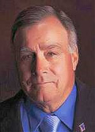Mr. Happel is a former County Commissioner in Madison County, Montana, and is an outspoken foe of the UN’s Agenda 21. Dan shows how this blueprint for tyranny parades under the guise of sustainable development but really is aimed at bringing all human activity under control of government ‒ supposedly justified by the myth of global warming. Dan is on the Leadership Council of Freedom Force International.

**Alex Newman**  
***They Call It News; Global Warming and Propaganda***

Mr. Newman is a journalist and co-author of the book *Crimes of the Educators: How Utopians Are Using Government Schools to Destroy America’s Children.* He has a keen understanding of the global-warming deception and shows how global-warming myth makers, embedded in schools and media organizations, follow Adolph Hitler’s axiom: If you tell a big enough lie and tell it frequently enough, it will be believed.

**Willy Soon**  
***Man*** **vs*. Sun; Put Your Money on the Sun***

Dr. Soon is a solar and astrophysics scientist and an editor for the journal *New Astronomy*. He co-authored a scientific paper, “The Maunder Minimum and the Variable Sun–Earth Connection”, that debunks anthropogenic global-warming from the perspective of astrophysics. Man’s effect on the Earth is puny compared to solar-storms. The record of climate change from 1645 to about 1715 confirms that global warming is caused by solar variation, not human activity.

**Istvan Marko**  
***CO2 Is Not Pollution. It is Our Friend.***

Dr. Marko is a professor of Chemistry at Catholic University of Louvain, Belgium. He says that everyone should be concerned about pollution of our air and water by toxic chemicals and unsightly waste products. However, CO2 is not in this category. CO2 is not a health hazard but is essential to the life cycle of plants and humans. More atmospheric CO2 actually would be healthy for us and good for increased food production. He has enraged the global-warming myth-makers by likening their belief system to a religion.

**New human organ discovered by Irish surgeon?**

USA Today Network [Sean Rossman](http://www.usatoday.com/staff/10054466/sean-rossman/) , USA TODAY

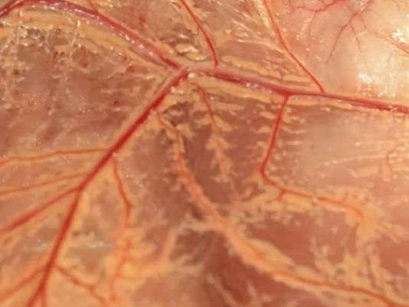An Irish surgeon's breakthrough overturned more than a century of medical belief and may lead to improvements in digestive surgery and recovery.

A mesentery.(Photo: Time)

The mesentery, it turns out, is one connected organ, not a disjointed group of separate parts, a theory believed since the 19th Century.  The mesentery connects the intestine to the abdomen.

J. Calvin Coffey, a professor at the University of Limerick, reclassified the mesentery after discovering it was contiguous. His [findings were published](http://www.thelancet.com/pdfs/journals/langas/PIIS2468-1253(16)30026-7.pdf) in November in the medical journal *The Lancet Gastroenterology and Hepatology.*

Although it has no identifiable function, clarifying the structure of the mesentery, the university said, makes way for better understanding of the organ.The university said mesentery research may lead to less invasive surgeries, fewer complications, shorter patient recovery and lower costs.

The findings suggest mesentery plays a central position in the body, which could lead to even more studies.

"Whether the mesentery should be viewed as part of the intestinal, vascular, endocrine, cardiovascular or immunological systems is so far unclear," the findings said, "as it has important roles in all of them."

Mesentery research goes back to the time of Leonardo DaVinci, who provided one of the earliest depictions of the mesentery, which was shown as contiguous. For centuries, the now-organ was depicted that way until the findings of Treves in 1885. His description of the mesentery — which was disconnected — became the basis of medical literature over the next century.

"During the initial research, we noticed in particular that the mesentery, which connects the gut to the body, was one contiguous organ," Coffey said. "Up to that it was regarded as fragmented, present here, absent elsewhere and a very complex structure. The anatomic description that had been laid down over 100 years of anatomy was incorrect."

The next step, Coffey said, is to determine the mesentery's function.

"If you understand the function you can identify abnormal function, and then you have disease," he said. "Put them all together and you have the field of mesenteric science... the basis for a whole new area of science."

**Editor’s Note: This story has some very interesting points to grab the attention of Creationists. First, contrary to the title’s implication, the human body has not evolved a brand-new organ. The mesentery is the same tissue present inside the human body for centuries, but until now, was not recognized as a functioning organ. This runs counter to the many inferences by evolutionary science that man has his body all figured out. Indeed, we are learning things about God’s creation all the time and that is when science is most meaningful.**

**Note, that even after identifying this tissue as a contiguous organ, researchers still cannot define all its functions. Much more research is needed to find how this organ interacts with the intestinal, vascular, endocrine, cardiovascular or immunological systems in some ways we do not yet understand. Indeed, doctors are still just “practicing” when it comes to a full understanding of God’s fantastic creation of the human body.**

**The scripture, Psalms 139:14 comes to mind where the Psalmist said, “I will praise thee; for I am fearfully and wonderfully made: marvelous are thy works; and that my soul knoweth right well.” KJV**

**How Old is the MOON?**

According to a new analysis of Apollo 14 lunar samples, it is estimated by conventional geologists that the moon is about 4.51 billion years old and they hold this age dating is extremely accurate. Below are excerpts from a study synopsis printed on space.com at <http://www.space.com/35291-moon-age-pinned-down.html> (go there for the full article)

A research team recently reported that the moon formed within 60 million years of the birth of the solar system. Previous estimates ranged within 100 million years, all the way out to 200 million years after the solar system's creation, not quite 4.6 billion years ago.

The scientists conducted uranium-lead dating on fragments of the mineral zircon extracted from Apollo 14 lunar samples. The pieces of zircon were minuscule — no bigger than a grain of sand. …

Lead author Melanie Barboni of the University of California, Los Angeles, noted that the moon holds **"so much magic ... the key to understand how our beautiful Earth formed and evolved." The moon was created from debris knocked off from Earth, which itself is thought to be roughly 4.54 billion years old.** (bold type mine)

On Monday, a separate group of Israeli scientists suggested our Earth's constant companion may actually be a melting pot of many mini-moons. Rather than one giant impact that shaved off a chunk of Earth and formed the moon, a series of smaller collisions may have created multiple moonlets that eventually merged into one, according to the researchers.

Barboni said regardless of how the moon came to be — one big strike at Earth, many smaller ones or even none at all — "you still end up at the end solidifying the moon as we know it today."

The giant impact theory holds that the resulting energy formed a lunar lava ocean that later became solid. It's this solidification age that Barboni and her team have now ascertained.

"We finally pinned down a minimum age for the moon formation," she said, "regardless of how it formed."

**Editor’s Note: Several points above show amazingly bad science being pushed by the University of California and NASA. First, of course, is the fact as we have detailed before in these Communiques that the radiometric dating techniques used in this study have been found to give wildly inaccurate dates 100% of the time when compared with known ages of rocks. There is no scientific basis whatsoever to believe in the dating conclusions they arrived at.**

**Second, note the bold type I highlighted in the article excerpt. “Magic… and how our earth evolved.” Boy, has this woman drank the Kool-Aid of the religion of evolution. She even states as fact in this highlighted excerpt the “Big Splash” theory of the moon’s formation, which the Israeli scientists take issue with just a few paragraphs later as not being fact.**

**Finally, what is never talked about in such study reports is how bad all this data is. When the initial moon rocks and soil samples came back on Apollo 11, the radiometric dates for these different samples varied wildly. Some samples dated to as little as 300 million years and some to as much as 12 billion years. Samples from later flights using these same radiometric techniques gave ages as old as 18 billion years.**

**Initially, in the early 1970’s a committee of NASA scientists evaluated this wildly disparate data and came to the conclusion that the moon was probably only about 3 billion years old since there was a grouping of some of the data around that figure. This estimate however caused all sorts of upheaval in the science community since it was nowhere near the age posited for the solar system and led to all types of “moon capture theories” and the like. A later committee supposedly solved this by voting that the moon was about 4 billion years old since some (not many) of the samples dated to this time, and this time frame fit better with their solar system and “Big Splash” formation theories. Note how subjective all of this is and how these dates are more the product of subjective human votes and feelings and making the data fit their theories, rather than unequivocal scientific data.**

**Creationist need not run from such terrible science. From analysis of the lunar recession (its moving away from us), analysis of what the Earth’s spin rate and shape would have been had there been a moon in close Earth orbit, “ghost craters” and so many more scientific observations indicate a very young moon as the Bible would suggest.**

**Texas votes to keep science lessons challenging evolution** Associated Press and onenewsnow.com

AUSTIN, Texas (February 3, 2017) — The Texas Board of Education has moved closer to tweaking — but still preserving — high school science curriculum requirements that teachers and academics say cast doubt on the theory of evolution.

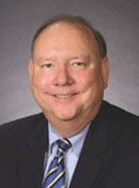After debating the issue earlier this week, the Republican-controlled board took its first binding vote Friday. It votes again in April. The board dropped language that asked biology students to consider "all sides" of scientific theory. Some academics said that let religious ideology trump science and might have left students believing God created life.

But the board inserted similar requirements on scrutinizing scientific conclusions. It kept lessons on the origin of life and gaps in the fossil record. Critics say the standards still challenge evolution.

The standards govern what's covered in Texas classrooms and can influence textbooks elsewhere.

**Editor’s Note: Praise be to the Lord and His leadership of our state school board and our fine state board representative Ken Mercer who many of you helped to re-elect in the last election. They continue to push for an honest dealing with scientific data about evolution, against wave after wave of opposition which seeks to silence such inquiry by our public-school children.**

Ken Mercer

**Science Workshops at FEAST in Spring 2017**

We thank all the many participants who attended the FEAST Science Workshop in January on **“Dinosaurs and the Bible”**

SABBSA president **Scott Lane** will present three more multimedia creation science presentations as selected by our FEAST participants at the FEAST Science Workshops in 2017. All presentations will be at 6:30 pm on the fourth Monday's of each month. A companion young children's "hands on" program is also provided each night by the Williams.

The schedule of programs this spring is shown below:

February 27, 2017 - **The Discovery of Genesis in Chinese**

March, 2017 - **Distant Starlight, Big Bang and the Bible**

April, 2017 - **Where did Cain get his Wife and other Supposed Biblical Contradictions**

**_______________________________________________________________________________**

**Coming February 23, 2017**

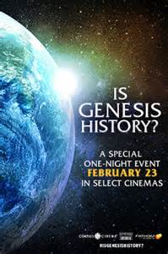**"Is Genesis History?" -** A Major Theater Documentary

"Nothing in the world makes sense except in the light of Genesis." - Del Tackett

What exactly happened, "In the beginning..." and in the time that followed? Throughout most of history, Genesis was considered an accurate and reliable record, but over the past 250 years, it has become one of the most controversial books of all time. Events highlighted-including the Creation of the universe in six days, the existence of the real Adam and Eve, and a global Flood destroying the world-are now questioned by man... including some Christians. Where can reliable, well-researched answers be found?

**New Documentary Shines New Light February 23** (One night only in major theaters around the country). We will have the film’s director, Thomas Purifoy on our radio show to talk about this important film at 1:45 pm on Saturday, February 18 on AM radio 630 KSLR.

IS GENESIS HISTORY? is a comprehensive documentary featuring scientists and scholars looking at the world and explaining how it intersects with the history recorded in Genesis. From rock layers to fossils to lions to stars, this fascinating film will challenge and change the way you see the world. Showing in theaters as a one-night event on Thursday, February 23 only, IS GENESIS HISTORY? shines new light on our origins, providing a positive argument for Biblical Creation and the Flood. Dr. Del Tackett, creator of "The Truth Project," serves as your guide-hiking through canyons, climbing up mountains, and diving below the sea-in an exploration of two competing view... one compelling truth.

This film will be shown at the San Antonio area theaters listed below, and presale of tickets are available on the film's website at **http://isgenesishistory.com/**

Embassy 14 - 13707 Embassy Row, San Antonio, TX  
The Santikos Rialto - 2938 Ne Loop 410, San Antonio, TX  
Silverado 16 - 11505 W Loop 1604 N, San Antonio, TX  
Santikos Bijou Cinema Bistro - 4522 Fredericksburg Road, San Antonio, TX  
Palladium IMAX - 17703 W IH-10, San Antonio, TX

Live Oak 18 - 7901 Pat Booker Road (I-35/Pat Booker), Live Oak, TX 78233

Huebner Oaks Stadium 14 - 11075 Interstate Highway 10 West, San Antonio, TX 78230

Northwoods 14 - 17640 Henderson Pass, San Antonio, TX 78232

Cielo Vista 18 - 2828 Cinema Ridge (Loop 410/Ingram), San Antonio, TX 78238

**___________________________________________________**

**San Antonio Biblical Worldview Conference**

Contending for the Faith that Was Once for All Delivered to the Saints  
Feb. 10 & 11, 2017  
Faith Lutheran Church, 14819 Jones Maltsberger, San Antonio, Texas  
210-494-7800

At the upcoming Biblical Worldview Conference of San Antonio (Feb. 10 & 11; www.worldviewSA.org), Christians will find they don't have to check their minds at the door or feel compelled to abandon their faith because of the supposed superiority of contemporary thought taught in schools, higher education, and popular culture. Presentations include:

- The Faith (the biblical worldview) Once for All Delivered to the Saints and how it compares to popular alternatives (Rev. David Jay Webber)  
- How the Chief Parts of Christianity Equip Christians to Face Any Future (Rev. Jonathan Fisk)  
**- What to Do When Anti-Christian Worldviews Infiltrate the Classroom (Dr. Ryan MacPherson)  
- How to Defend the Faith that was once for all delivered to the Saints (Atty. Craig Parton)**

Everyone is warmly welcomed, including students (high school on up), parents, grandparents, pastors, teachers, and any interested Christian. For more info and to register go to **www.worldviewSA.org**.

**Schedule**  
Friday evening, Feb. 10, 2017:  
- 7:00 Worship: Office of Compline  
- 7:30 Social hour with presenters  
Saturday, Feb. 11, 2017:  
- 9:00 Welcome  
- 9:15 Rev. David Jay Webber: The Faith that Was Once for All Delivered to the Saints  
- 11:00 Rev. Jonathan Fisk: Midst; Flaming Worlds in These Arrayed: How the Chief Parts of Christianity Equip You to Face Any Future  
- 12:10 Lunch (served at the church)  
- 1:30 **Dr. Ryan MacPherson: What to Do When Anti-Christian Worldviews Infiltrate the Classroom**  
- 3:10 Attorney Craig Parton: Defending the Defense of the Faith  
- 4:50 Table Talk (Q and A with presenters)  
**Cost: $30 (students), $60 (adults), $95 (families); lunch included in the cost**.

We will have the leader of this conference, Pastor David Thompson on our radio show to discuss this event on Saturday, February 4 at 1:45 pm on radio station AM 630 KSLR. We invite you to listen in.

**SABBSA on KSLR**

Please join the San **Antonio Bible Based Science Association** as we are now “on the air” each Saturday afternoon with “**Believing the Bible!”** Join us **Saturday afternoons at 1:45 pm on radio station KSLR 630 AM**.

Here is our schedule of program topics for the start of 2017:

Feb. 4 - **San Antonio Biblical Worldview Conference**  
Feb. 11 - **Are we Made of Stardust?**  
Feb. 18 - **"Is Genesis History?"**  
Feb. 25 - **Captured Moon?**  
Mar. 4 - **Choose a Bathroom**  
Mar. 11 - **Mars Flood?**  
Mar. 18 - **Is Evolution Science?**  
Mar. 25 - **The Haeckel Hoax**  
Apr. 1 - **Can TNT Create Us?**

There are several ways you can help with this exciting new endeavor. One and always first is pray for this program, for its content, its producers and impact. Second, become a sponsor, as many of our board members have done and help us defray the $60+ per week costs of putting this program on the air. Third listen to this show on the air and tell your friends and family members, so this can reach as wide an audience as possible. Fourth, help us with scripts. We are hoping that our board and other interested and knowledgeable members will both tell us what they would like to hear in future programs as well as help us by writing future scripts and coming on the air with us to make this truly a group effort.

Also, we now have an opportunity to take this program and broadcast it in radio stations across the country. To do that though we need sponsors to underwrite it at the very modest cost of $303 per month. Contact us at 210-861-0454 if you would like to help and expand our ministry in this way.

This program is available on podcast. If you cannot tune in on Saturday afternoons, or would like to sample our program or hear previous shows, they are available on podcast on the KSLR website. Click on the link below to go to the KSLR podcast page and scroll down till you find "Believing the Bible."

["Believing the Bible" - SABBSA on KSLR Radio](http://kslr.com/podcasts)

Please join us each Saturday at 1:45 pm on radio KSLR 630 AM for **“Believing the Bible.**

**This Spring at SABBSA**

Please join the **San Antonio Bible Based Science Association** this winter as we provide exciting video presentations in creation science! Our monthly meetings occur on the second Tuesday of each month at 7 pm at the Jim's Restaurant at the corner of San Pedro and Ramsey.

Here is our schedule of programs this winter:

February 14, 2017 - **"Fallout" + "Debunking Evolution"**  
March 14, 2017 - **Climate Change**

April 11, 2017 - **Uncovering the Truth about Dinosaurs**, parts I & II

May 9, 2017 - **Uncovering the Truth about Dinosaurs**, parts I & II

**__________________________________________**

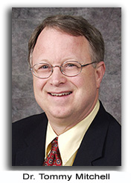**Coming February 19-20, 2017**

**Answers in Genesis at Fellowship Bible Church**

Sunday, February 19 - Monday, February 20, 2017

**Free Creation Conference with Dr. Tommy Mitchell of Answers in Genesis.**   
Sessions will be held Sunday, February 19, 2017 at 9:30 and 10:45 AM and 6:00 and 7:30 PM;

Monday at 9:30 am for grade K-6, 11 am grades 7-12, an evening all ages sessions at 6:30 and 8 PM.

Location: Fellowship Bible Church, 8603 Huebner Road. San Antonio, TX 78023  
210-699-6511 **_______________________________________**

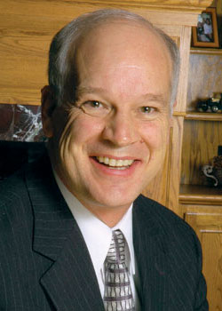**Coming March 19, 2017**

**Del Tackett ("Is Genesis History" host and the "Truth Project") at Fellowship Bible Church**

**Del Tackett will speak on three separate topics at Fellowship Bible Church.**mSessions will be held Sunday, March 19, 2017 at 9:30 and 10:45 AM and 6:30 PM. The public is welcome and this event is free.

Location: Fellowship Bible Church, 8603 Huebner Road. San Antonio, TX 78023 210-699-6511

**Prayer Needs and Praises!**

**SABBSA** for prayer, support and guidance as we consider expanding our radio ministry.



**Cartoon Corner**

Thanks to **Answers in Genesis** who provides these cartoons each month for our newsletter and our presentations. Please think about donating to them in gratitude for this and all the ministries they give us.

**Around Texas**

**Houston:**   
The **Greater Houston Creation Association** (**GHCA**) meets the first Thursday of each month. They meet at Houston's First Baptist Church at 7 pm, in Room 143. After the presentation, there will be refreshments, fellowship and creation science materials for all to enjoy. Their meetings can be streamed live! For more information, go to [www.ghcaonline.com](http://r20.rs6.net/tn.jsp?llr=bztaencab&et=1103662222545&s=545&e=001xF-6WOYzM5Yyre44Ea_qUjH5EOT_fFIGjrfpfa5h-rD53IlUVbz3Vc0Dp47_VEwW3iQQ6F1b6K0EtKc_vUxYKpzN_8V2upXFbsOScvUeD92nJdUTjDIFeg==).

**Glen Rose:**   
Dr. Carl Baugh gives a “***Director’s Lecture Series***” on the first Saturday of each month at the Creation Evidences Museum just outside Glen Rose, TX. The new and improved museum is also a great and beneficial way to spend any day. Presentations are at 11 am and 2 pm. For more information, go to [www.creationevidence.org](http://www.creationevidence.org)

**Dallas-Ft Worth:**   
The Metroplex Institute of Origin Science (MIOS) meets at the Dr. Pepper Starcenter, 12700 N. Stemmons Fwy, Farmers Branch, TX, usually at 7:30 pm of the first Tuesday of each month.

**Lubbock Area (Crosbyton):**   
All year: Consider a visit to the Mt. Blanco Fossil Museum, directed by Joe Taylor. The Museum is definitely worth the visit if you live near or are traveling through the Panhandle near Lubbock. If you call ahead and time permitting, Joe has been known to give personal tours, especially to groups. For more information, visit [http://www.mtblanco.com/](http://r20.rs6.net/tn.jsp?llr=bztaencab&et=1103662222545&s=545&e=001xF-6WOYzM5bqqt6T1G_CwJWJosrOSIhLAagtnP0Z504J-gEROEBe22S3gq720x6ofjFVqK-AfJcsjrsuQyRtoepYiAQVVUFC-cF56fLwwBJ0SQ-44KlLmw==).

**Greater San Antonio area:** Listen to **Answers with Ken Ham** online at the address below. (No nearby station for this broadcast). <http://www.answersingenesis.org/media/audio/answers-daily> To hear program from the **Institute for Creation Research**, listen online at this address. <http://www.icr.org/radio/>Also, tune in KHCB FM 88.5 (San Marcos) or KKER FM 88.7 (Kerrville) for **Back to Genesis** at 8:57 AM Mon-Fri, then **Science, Scripture and Salvation** at 1:30 AM, 8:00 AM and 4:30 PM on Saturdays.

[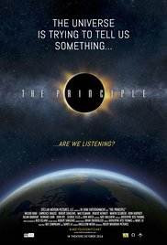](http://www.imdb.com/title/tt2458876/mediaviewer/rm173865728?ref_=tt_ov_i)**Last Month at SABBSA**

**The Principle** (major theater documentary film)

"The Principle" brings to light astonishing new scientific observations challenging the Copernican Principle; the foundational assumption underlying the modern scientific world view. The idea that the Earth occupies no special or favored position in the cosmos has launched the last two scientific revolutions - the Copernican Revolution and Relativity - and, as Lawrence Krauss has said, we could be on the verge of a third, with "Copernicus coming back to haunt us". Interviews with leading cosmologists are interspersed with the views of dissidents and mavericks, bringing into sharp focus the challenges and implications not only for cosmology, but for our cultural and religious view of reality.

We evaluated this film as doing an excellent job of describing some very intriguing data which points to a biblically compatible geocentric universe framework.

**Next SABBSA Meeting:   
Tuesday, February 14, 2017, at 7 pm**

**Coming to SABSA in February**

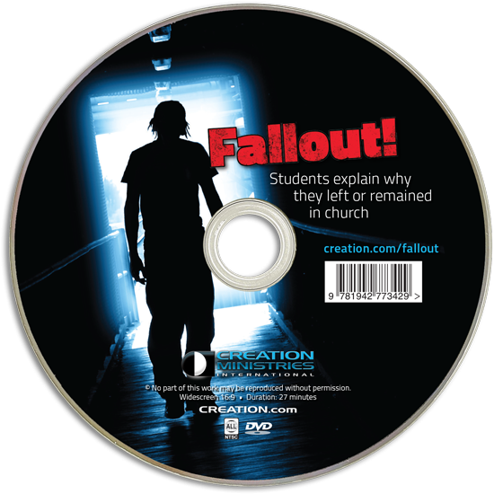**"Fallout" + "Debunking Evolution"**

In February, we will see two videos designed to bring our youth and millennials back into the church.

**Fallout**  
Why do so many young people walk away from the church? What can be done to retain them? In this short but powerful documentary, CMI conducted interviews with students on university campuses to have them explain, in their own words, whether they were taught about the evidence for creation, and how this impacted them. A clear pattern emerged-those who were equipped to defend biblical creation remained faithful, while those who did not abandoned the church. In addition, Fallout! answers the evolutionary arguments offered by the students. As their testimonies reveal, equipping students with a defense of creation can have a huge impact on their faith.

[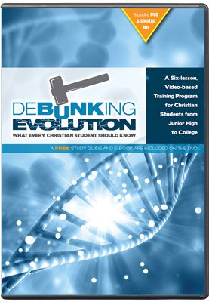](https://assets.answersingenesis.org/img/prod/primary/lg/30-9-553.jpg)**Debunking Evolution**   
Join study partners, John and Jane as they explore the challenges to the evolutionary theory and why the Bible makes the most sense of the scientific evidence. The program helps students understand the weak foundations of evolution, teaching them a strong case for the truth of Biblical Creation. Available for downloading online at <http://genesisapologetics.com/debunking-evolution-series/>

Both videos are recommended for use with church leaders and church youth groups. **We ask you to invite your pastor or youth leader to come to this meeting.**

Please join us in February for creation science and biblical apologetics teaching you will find nowhere else in Bexar County. As always, we will meet at the Jim’s restaurant at the corner of San Pedro and Ramsey.