Communique'

President - Scott Lane 599-7240 Vice President – Al(den) Johnson, O.D.   
Secretary – Clarence Johnson Treasurer – Carl Williams, M.D.   
[website – [www.sabbsa.org](http://www.sabbsa.org) ] [P.O. Box 34478, San Antonio, TX 78265]

**April 2017**

We at the **San Antonio Bible Based Sciences Association** (SABBSA) hope and pray that you and yours are all experiencing the renewal of spring and are in happy anticipation of Easter. This is a time of year when we can focus on what Christ did for us on the cross. Our society wants to lose this message in Easter bunnies and new clothes, but as always with prayer and supplication we can keep our eyes on what He did for us if we will just focus.

Speaking of how Satan tries to distract us from Christ’s message, we have an article about a website which shows a lot of Greek art and mythology which testifies to their knowledge of Genesis in ancient times and how even then this knowledge was skewed and transposed to tell the stories they wanted instead of the truth of the father. In spite of these efforts, such art and literature today stands as a testament to the Genesis account being the forbearer of all other creation accounts as it should be since it was the original and the only factual account of the creation as told by the only eye witness.

We also have an article on just how short a time fossilization can occur which shows that the world we live in can be just thousands of years old and yet look quite old. Finally, we have a very special article on the symbiotic relationship between wasps and fig trees. This story not only gives great evidence of God’s almost infinite design’s in nature, but also teaches a deep theological truth.

Of course, we have a full rundown of all the upcoming creation events around Bexar County and beyond. We at SABBSA are in eager anticipation of the next three months when we are scheduled to give ten creation presentations to a wide variety of audiences as well as broadcast 13 radio programs. Our group will be the featured creation group and presenters at the FEAST Home School Conference this June. We also have been given a very rare opportunity to speak to secular civic audience. We hope and pray you find something in this newsletter which helps you in your walk with Christ.

**The Amazing Stone Bears of Yorkshire**

by [Dr. Monty White](https://answersingenesis.org/bios/monty-white/)

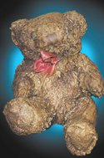*Originally published in* Creation *24, no 3 (June 2002): 48-49.*

*When Vet author James Herriot wrote about life in Yorkshire last century, he probably had no idea that this area of England held a fascinating key to unlocking one of the myths of evolution’s long-age ideas.*[[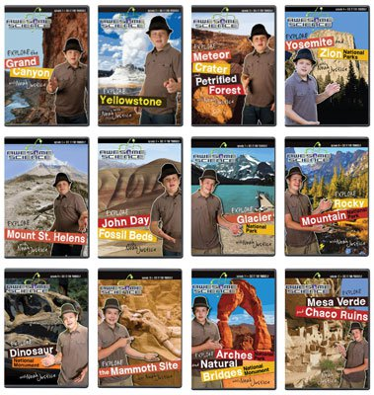](https://answersingenesis.org/store/product/awesome-science-volumes-1-12/?sku=40-1-485)Shop Now](https://answersingenesis.org/store/product/awesome-science-volumes-1-12/?sku=40-1-485)

I was surprised to read recently that small teddy bears placed under a waterfall in Yorkshire “turned to stone” in three to five months. After all, I had been told by my geology lecturers at university that stalactites and stalagmites take many thousands of years to form, so how could teddy bears petrify so quickly? So, I decided to investigate these claims and take a trip to Knaresborough, a town some 13 miles west of York, England.

When I saw the stone teddy bears hanging under the waterfall, along with clothes, top hats, shoes, trainers and even an umbrella, I realized that I was observing an amazing geological spectacle. I couldn’t resist adding an Answers in Genesis necktie to the line-up.

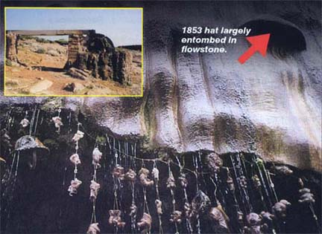Known variously as the “Dropping Well" and then the “Dripping Well”, this fascinating attraction has drawn curious visitors for hundreds of years. Note the myriad hanging pieces which people have added over the years. It is like the Petrified Waterwheel (*inset*) in Australia’s west which has become totally encased in stone in only several decades.

The so-called Petrifying Well at Knaresborough has been a tourist attraction since 1630. Its water originates underground and has a high mineral content. As the water splashes onto the hanging objects, the mineral calcite (calcium carbonate) is deposited along with small amounts of other minerals. Gradually, these deposits build up and coat the object with a crust of rock.

The time needed for petrification depends on the size and porosity of the object. Small teddy bears take between three and five months. Larger porous items (large teddy bears and clothing) take six to 12 months. Non-porous items such as a top hat or a fireman’s helmet can take up to 18 months to be encased in stone.

The most impressive petrified objects are now just two bulges sticking out of the flowstone. These are the remains of a Victorian top hat and a lady’s bonnet left at the waterfall in 1853—some 148 years ago! These hats are now completely covered in a thick layer of flowstone—so much for its taking thousands of years for such flowstone thicknesses to form!

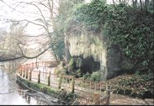The Beautiful “Dripping Well” of Yorkshire

As I surveyed the petrified teddy bears at Knaresborough, I thought about how often I had been fed the myth that petrification needs millions of years. The Creator asked Job (*Job 38:4*), in effect, “Were you there when I laid the foundations of the Earth?” Taking this as our cue, we need to challenge those who promote millions of years, “Were you there to observe these processes taking place?” There, at the Petrifying Well, I observed first hand that objects can petrify in months and years. Those teddy bears demolish a powerful cultural myth that prevents people believing what the Bible says about the true age of the Earth.

**Symbiotic Relationships of fig Trees and Wasps – Amazing!**

While at the March 19 talk by Del Tackett here in San Antonio, he related a story about how there were hundreds of species of fig wasps and hundreds of varieties of fig trees which all corresponded and were pollinated only by a certain species of fig wasp and none other.

Of all the symbiotic relationships I had ever heard of, this was one of which I was not aware. Symbiotic relationships are one of the best evidences of God’s designs in nature. Thus, I checked it out and found its quite true! Incidentally, if you do not know about this relationship, you may want to quit reading as you may not ever eat a fig again.

As it turns out, about 900 species of “fig wasps” have been identified across the world, as well as about 900 species of fig trees. Each species of fig wasp is adapted to and will only burrow into and pollinate one specific species of fig tree. For example, fig wasp #8 will only burrow into and pollinate fig tree species #8 and fig wasp species #465 can identify fig tree type #465 and will only pollinate it.

If that is not complex enough to show that this incredible relationship was designed by a Creator, then the details will impress you even more.

[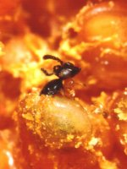](http://www.figweb.org/Ficus/images/Ceratosolen_capensis_emerging_400.jpg)Fig wasps queens are fitted with back pointing teeth on the backs of their hind limbs and mandibles. These backward teeth allow the queen to back into and burrow into the natural hole already designed into every fig. She is also aided in this task by the elongated and flattened shape of her thorax and head which are well designed to help her slip in. In the process, she will often rip off her wings and antennae. This does not however deter her from pollinating the fig species once she has embedded herself, and laying her eggs within the fig.

*Ceratosolen capensis* femaleemerging from her gall inside a fig of *Ficus sur*.

The female wasp then proceeds to pollinate the stigmas and to lay eggs in the ovules of some of the florets. This she does by inserting her long ovipositor down the inside of the style (this is an intentional act she is predesigned and programmed to accomplish). The florets that have styles longer than the wasp’s ovipositor are pollinated, but no eggs are laid in the ovule and hence these florets set seed. The wasp larvae feed on the endosperm tissue in the galled ovary and larval development correlates strongly with host fig development, encompassing anything from three to twenty weeks.

Once the wasps have reached maturity they chew their way out from the galls and emerge into the fig cavity within a short period of each other. The wingless males mate with the females before chewing a hole through the fig wall to the exterior to allow the females to escape. These are the male’s only two functions in life, as he dies soon afterwards! The females either actively load up pollen from ripe anthers into special pollen pockets, or in some species passively become covered with pollen, before exiting the fig in search of young receptive figs to complete the cycle. (http://www.figweb.org/Interaction/How_do_fig_wasps_pollinate/)

Now, let’s examine how well and intricately designed all of this is. If the wasps did not have back teeth they could not burrow into the fig. Without the predesigned opening in the fig they could not get in. Without flattened and elongated bodies from the start they could not accomplish this process. If this occurred by chance evolution the first several times this was tried the suicidal wasp would try and deposit her eggs into an unknown area and kill herself in the process as she lost her wings and antennae. Since she did not yet have the preprogramming (instinct) nor plumbing needed to deposit the pollen into the proper place in the fig she would die, her eggs might not be laid or hatch and the tree would not be pollinated. This scenario for evolution does not further either species.

Even if she accidentally had backward teeth on her body for no apparent reason, burrowed backward into the fig not for her own food, but to lay her eggs for her young and could somehow differentiate already between the one species of tree out of 900 which she was to pollinate, and she magically had already constructed on her the long ovipositor with which she will pollinate the fig as well as lay her eggs this cycle will still fail. This because in the early stages of an evolutionary scenario, the males would not be preprogrammed to eat their way out to clear the way for the new queens which have to have a clean tunnel for them to exit with pollen still on them to deposit elsewhere. Nor would the carefully controlled balance of males and female eggs be produced and lad which make this whole process in the fig possible.

I have heard of a lot of incredible symbiotic relationships such as with the Egyptian Plover and the Nile Crocodile, sharks and feeder shrimp, but nowhere else have I seen such a relationship so finely configured on both sides, not once but 900 times revealing the Creator’s hand each and every time.

This myriad set of relationships is a fascinating set of evidences for God’s designs in nature and His existence, but it is not the whole story Del Tackett was getting to that night. You see there was a theological story being revealed in this relationship as well.

God created all of us to bear fruit. But, that fruit is almost never for ourselves, but for the benefit of others. Likewise, the fruit on the fig tree is not for the fig tree, but for the wasp and her young. We too benefit from the fruit of the fig trees (although I don’t know after reading this if you will ever eat one again).

I was always bothered by the story in the Bible where Jesus came upon a fig tree [Matthew 21:18-22](https://biblia.com/bible/esv/Matt%2021.18-22), and then also in [Mark 11:12-14](https://biblia.com/bible/esv/Mark%2011.12-14) which had no fruit and he cursed it and it withered by the next day. This always seemed to me to be a petulant, if not sinful thing to do. But, if we understand not only His need for food, but also the truth that He (the Creator) created everything, including that tree, to produce fruit, it is understandable that He would curse anything which was not functioning as designed. Similarly, even though He designed and created us and loves us, if we do not follow Him and produce fruit in our lives as He designed, He will also curse us for not fulfilling our destinies as He designed them.

God gave us many wonderful things with the fig trees and fig wasp, but also with the entire creation. His designs are a living testament to His unique creative powers. But, they also are designed to exhibit for us the purposes of His creation. The purposes that all of us are to live for others and live symbiotically. If we or nature fails to fulfill what we are designed for, we doom ourselves.

This is just one of many new teaching threads in a new teaching series Del Tackett will be putting out soon called “**Engagement**.” We are excited by this new series and pray for its positive impact in our world.

**Return to the Garden**

There is a fascinating website which gives numerous examples of Greek art which depicts Genesis characters in them. This website can be perused at <http://genesisingreekart.com/Genesis_in_Greek_Art/Table_of_Contents.html>

The depictions are often of how the line of Seth or Noah were conquered allowing the other gods to flourish and mankind to break with Jehovah. Indeed the art does not extoll Jehovah God, but tries to explain our break from him, but what it does do is show the influence of the book of Genesis on Greek Art circa 410 BC. Such art not only gives us good evidence of the biblical accounts existing far before these Greek myths, but also give us evidence that the modernist claims that the whole of the Torah including Genesis were redacted around this time. The dissemination of all the Genesis knowledge depicted in this art shows that these accounts had been around for centuries.

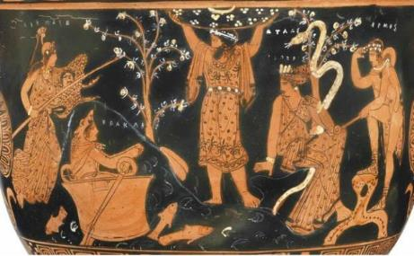On this vase from 410 BC, this artist depicted an imagined family reunion, celebrating the triumph of the way of Cain in the post-Flood world.

The scene takes place in the Garden of the Hesperides, the Greek version of Eden. An Hesperid (nymph of the West) tends the serpent-entwined apple tree (Genesis doesn’t say what kind of tree it was; it’s from the Greek tradition we get the idea Eve ate an apple).

In the center we see Lamech/Atlas pushing away the heavens, and with them the God of the heavens, preferring to live under the authority of the serpent who told his ancestor Eve/Hera “Ye shall be as gods.” Lamech (Genesis 4:22) was the last king of the Cainite world before the Flood.

Lamech’s daughter, Naamah/Athena (also Genesis 4:22), the link between the pre-Flood and post-Flood worlds, came through the Deluge as Ham’s wife, and instigated and directed the successful rebellion against Noah and his God-fearing offspring.

Here, Naamah has figuratively come back through the Flood, bringing her son Cush/Hermes (far right) and her grandson Nimrod/Herakles with her, both fully dedicated to the way of Cain.

Cush/Hermes carries his kerykeion with the two serpents at its end signifying the serpent’s rule in the age before the Flood and now in the age after it.

Nimrod/Herakles, wearing his lion’s skin, has paddled his way through the water in the bowl of the sun, suggesting a passage back through time. After Nimrod/Herakles routed the line of Seth on behalf of his grandmother Naamah/Athena in the post-Flood world, Greek sculptors pictured Lamach/Atlas figuratively presenting the fruit of the serpent’s tree to his great-grandson, Nimrod/Herakles, as a sign that the latter had earned the right to rule post-Flood humanity in accord with the way of Cain—the Creator pushed away and mankind exalted.

The basic message of the above scene: the royal line of Cain through Lamech and his daughter Naamah has reestablished its rule in the post-Flood world—without God, and in accord with the serpent’s “enlightenment.”

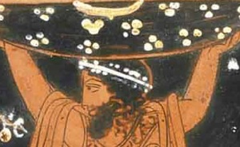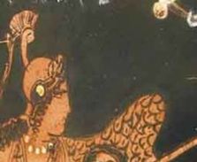

In these close-ups, a stern-looking Naamah/Athena, fresh from her victory over the line of Seth, and wearing her war helmet and carrying her spear, reports the triumph to her Cainite father, Lamech/Atlas, as he smiles back with pride and pleasure at his daughter’s great achievement.

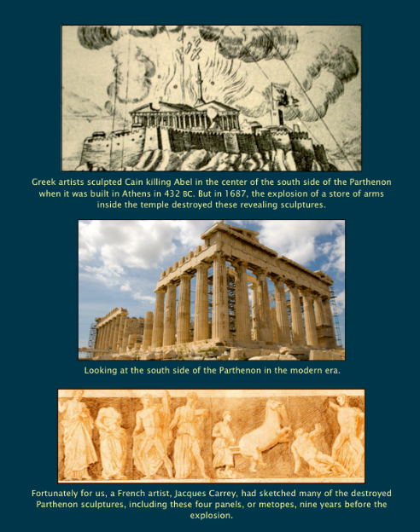Again, it must be emphasized how skewed these tales depicted on this art and told in ancient Greek mythology are from the original Genesis accounts. But, that of course is to be expected with the input of time, word of mouth retelling and the transfer and transposition of these accounts into Greek mythos.

Never the less, these Greek myths show a consistent pattern of reflecting man’s wish to break from God. Sadly, this has been a major theme for all cultures throughout man’s history.

Another example of what you will find on this website is shown at left. These artifacts are very consistent with what we find from cultures all over the world of art and literature depictions weaving biblical characters into their mythology and attesting to the fact that Genesis was the first creation account and the one they expanded upon. Both the Gilgamesh Epic, and the Babylonian Enuma Elish, from around 1800 BC, are some of the oldest of these finds always revealing an intricate knowledge of the first creation accounts in Genesis and weaving them into their mythos.

**This Spring at SABBSA**

Please join the **San Antonio Bible Based Science Association** this winter as we provide exciting video presentations in creation science! Our monthly meetings occur on the second Tuesday of each month at 7 pm at the Jim's Restaurant at the corner of San Pedro and Ramsey.

Here is our schedule of programs this winter:

April 11, 2017 - **Uncovering the Truth about Dinosaurs**, parts I & II

May 9, 2017 - **Uncovering the Truth about Dinosaurs**, parts I & II

June 11, 2017 - **Climate Change**

**SABBSA on KSLR**

Please join the San **Antonio Bible Based Science Association** as we are now “on the air” each Saturday afternoon with “**Believing the Bible!”** Join us **Saturday afternoons at 1:45 pm on radio station KSLR 630 AM**.

Here is our schedule of program topics this spring 2017:

Mar. 4 - **Choose a Bathroom**  
Mar. 11 - **Mars Flood?**  
Mar. 18 - **Is Evolution Science?**  
Mar. 25 - **The Haeckel Hoax**  
Apr. 1 - **Can TNT Create Us?**

Apr. 8 – **Prosecutor for Evolution**

Apr. 15 – **Intro. Carl Kerby, Reason for Hope**

Apr. 22 – **Carl Kerby, Reason for Hope**

Apr. 29 – **Carl Kerby, Youth Camps**

May 6 – **Limited**

There are several ways you can help with this exciting new endeavor. One and always first is pray for this program, for its content, its producers and impact. Second, become a sponsor, as many of our board members have done and help us defray the $60+ per week costs of putting this program on the air. Third listen to this show on the air and tell your friends and family members, so this can reach as wide an audience as possible. Fourth, help us with scripts. We are hoping that our board and other interested and knowledgeable members will both tell us what they would like to hear in future programs as well as help us by writing future scripts and coming on the air with us to make this truly a group effort.

Also, we now have an opportunity to take this program and broadcast it in radio stations across the country. To do that though we need sponsors to underwrite it at the very modest cost of $303 per month. Contact us at 210-861-0454 if you would like to help and expand our ministry in this way.

This program is available on podcast. If you cannot tune in on Saturday afternoons, or would like to sample our program or hear previous shows, they are available on podcast on the KSLR website. Click on the link below to go to the KSLR podcast page and scroll down till you find "Believing the Bible."

["Believing the Bible" - SABBSA on KSLR Radio](http://kslr.com/podcasts)

Please join us each Saturday at 1:45 pm on radio KSLR 630 AM for **“Believing the Bible.**

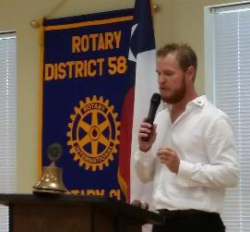**SABBSA at the Boerne Rotary Club**

Scott Lane has been asked to present a short version of his **DeFaithing of America** multimedia presentation to the **Boerne Rotarians on Friday, May 12th at 12 noon** atthe Kronkosky Center in Boerne located at 17 Old San Antonio Rd, Boerne, TX 78006. Anyone who wishes to join him may do so and enjoy lunch provided with the Rotarians.

Pictured at right is Mr. Josh Koviak, President of the Boerne Rotary Club.

This is a very rare opportunity for the SABBSA president to address a secular civic audience. We thank Boerne Rotarian, Mr. Chris Byrd, a Boerne lawyer who saw this presentation on YouTube and worked to bring it to Boerne.

**Prayer Needs and Praises!**

**SABBSA** for prayer, support and guidance as we consider expanding our radio ministry.

**Science Workshops at FEAST in Spring 2017**

SABBSA president **Scott Lane** will present the last multimedia creation science presentation this spring at the FEAST Science Workshops on April 24th. FEAST is located at 25 Burwood Lane, S. A., TX 78216. This presentation will be at 6:30 pm. A companion young children's "hands on" program is also provided by the Williams.

April 24, 2017 - **Where did Cain get his Wife and other Supposed Biblical Contradictions**

**SABBSA at the FEAST Home School Convention in June!**

SABBSA is excited to announce our participation as the only creation presenter at the **FEAST Home School Convention** this June! Convention Date: June 8 – 10, 2017

**Times**:

 – Thursday, June 8, 6pm – 9pm (free conference admission on Thursday evening only)

–  Friday and Saturday, June 9 –  10, 9am – 5pm

**Location**: FEAST Campus at 25 Burwood Lane, San Antonio, TX  78216

SABBSA President Scott Lane will do five presentations in the creation science field and we will have a booth offering creation science materials ranging from free to half price. You will not have a chance this year to get your hands on this range of creation science and biblical apologetics materials at these prices or even for free!

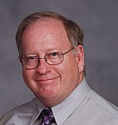

The schedule of presentations is listed below:

**Friday, June 9**

10:45 am **“What If God Wrote the Bible?”,** part I

12:30 pm **“What If God Wrote the Bible?”,** part II

Saturday, June 10

9:15 am **“Underpinnings: Fossils, Physics and Genetics”**

12:30 pm **“Biology and Intelligent design: Animals that Defy Evolution”**

3:30 pm **“Biology and Missing Links: Lucy Unveiled”**

Admission prices for the convention Friday and Saturday. FEAST Patriot Pass Holders are admitted to the convention free of charge. Non-Patriot Pass holders - $30 for one adult, $35 for a couple if paid online before May 31 (after May 31 or at the door add $5). Children are $10 each.   
Special prices are for parents of preschoolers, family passes and for children’s and teen special programs at the convention. Go to the FEAST registration page for more information or to register at <https://homeschoolfeast.com/o-events/convention/convention-registration/>



**Cartoon Corner**

Thanks to **Answers in Genesis** who provides these cartoons each month for our newsletter and our presentations. Please think about donating to them in gratitude for this and all the ministries they give us.

**Around Texas**

**Houston:**   
The **Greater Houston Creation Association** (**GHCA**) meets the first Thursday of each month. They meet at Houston's First Baptist Church at 7 pm, in Room 143. After the presentation, there will be refreshments, fellowship and creation science materials for all to enjoy. Their meetings can be streamed live! For more information, go to [www.ghcaonline.com](http://r20.rs6.net/tn.jsp?llr=bztaencab&et=1103662222545&s=545&e=001xF-6WOYzM5Yyre44Ea_qUjH5EOT_fFIGjrfpfa5h-rD53IlUVbz3Vc0Dp47_VEwW3iQQ6F1b6K0EtKc_vUxYKpzN_8V2upXFbsOScvUeD92nJdUTjDIFeg==).

**Glen Rose:**   
Dr. Carl Baugh gives a “***Director’s Lecture Series***” on the first Saturday of each month at the Creation Evidences Museum just outside Glen Rose, TX. The new and improved museum is also a great and beneficial way to spend any day. Presentations are at 11 am and 2 pm. For more information, go to [www.creationevidence.org](http://www.creationevidence.org)

**Dallas-Ft Worth:**   
The Metroplex Institute of Origin Science (MIOS) meets at the Dr. Pepper Starcenter, 12700 N. Stemmons Fwy, Farmers Branch, TX, usually at 7:30 pm of the first Tuesday of each month.

**Lubbock Area (Crosbyton):**   
All year: Consider a visit to the Mt. Blanco Fossil Museum, directed by Joe Taylor. The Museum is definitely worth the visit if you live near or are traveling through the Panhandle near Lubbock. If you call ahead and time permitting, Joe has been known to give personal tours, especially to groups. For more information, visit [http://www.mtblanco.com/](http://r20.rs6.net/tn.jsp?llr=bztaencab&et=1103662222545&s=545&e=001xF-6WOYzM5bqqt6T1G_CwJWJosrOSIhLAagtnP0Z504J-gEROEBe22S3gq720x6ofjFVqK-AfJcsjrsuQyRtoepYiAQVVUFC-cF56fLwwBJ0SQ-44KlLmw==).

**Greater San Antonio area:** Listen to **Answers with Ken Ham** online at the address below. (No nearby station for this broadcast). <http://www.answersingenesis.org/media/audio/answers-daily> To hear program from the **Institute for Creation Research**, listen online at this address. <http://www.icr.org/radio/>Also, tune in KHCB FM 88.5 (San Marcos) or KKER FM 88.7 (Kerrville) for **Back to Genesis** at 8:57 AM Mon-Fri, then **Science, Scripture and Salvation** at 1:30 AM, 8:00 AM and 4:30 PM on Saturdays.

**__________________________________________________________**

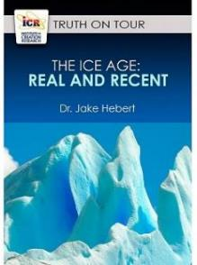

**Last Month at SABBSA**

We apologize for the sudden and unavoidable scheduling change which did not allow for our **Climate Change** discussion last month. That presentation has been moved to June. We are gratified that many in attendance benefited from the presentation of the **Institute for Creation Research** video **"Ice Age: Real and Recent".**

In that fine video, we found that an ice age does fit with biblical history. ICR's Dr. Jake Hebert explained how the assumption of millions of years is built into secular dating methods, and how circular reasoning is used to make sure the dates match evolution's "story."

The Ice Age covered nearly a third of Earth's land surface in snow and ice.  Creationist theory and good data shows there was only one ice age, rather than the multiple ice ages theorized by contemporary scientists. And, that ice age was likely caused by the global flood described for us in the Bible. In fact, that is the best explanation yet found for how an ice age could occur on Earth.

Secular scientists claim that hundreds of thousands of annual layers have been identified in ice cores from Greenland and Antarctica.  They also say that chemical clues in ice and ocean floor sediments tell a consistent story of climate change over millions of years.  Isn't this a powerful argument for an old earth?

ICR's Dr. Jake Hebert explains how the assumption of millions of years is built into secular dating methods and how circular reasoning is used to make sure the dates match evolution's 'story.'  In truth, the scientific evidence shows that while secular science fails to explain the Ice Age, the Bible provides real answers.

**Next SABBSA Meeting:   
Tuesday, April 11, 2017, at 7 pm**

**"Uncovering the Truth about Dinosaurs" -** Episodes 1 & 2

We know dinosaurs existed, because we've discovered their footprints and fossilized bones. But the facts of their existence, and their extinction, remain shrouded in mystery. What were the dinosaurs? When and where did they live? How and when did they die? And why does it matter to Christians? The answers to these mysteries are buried in Earth's layers and revealed in the pages of the Bible.

ICR's new DVD series **Uncovering the Truth about Dinosaurs** offers compelling evidence about dinosaurs that confirms the biblical account of Genesis. Produced by the **Institute for Creation Research**, this four-episode DVD series examines evidence from paleontology, geology, biology, archaeology, and history to get to the bottom of the story and unearth the real truth about dinosaurs.

We will view this series in two parts over the months of April and May 2017. At our April meeting we will view and discuss episodes 1 and 2 which are detailed below.

**Episode 1: Digging into Dinosaurs**  
Experts reveal intriguing information about favorite dinosaurs like T. rex and Triceratops, while host Markus Lloyd explores a fossil dig.

**Episode 2: Dinosaurs and Dragons**  
Compelling evidence from around the world suggests dragons were dinosaurs that lived in the not-so-distant past.

To preview video clips of these episodes go to: <http://www.icr.org/UncoveringtheTruthaboutDinosaurs/>

Please join us in April for creation science and biblical apologetics teaching you will find nowhere else in Bexar County. As always, we will meet at the Jim’s restaurant at the corner of San Pedro and Ramsey.