Communique'

President - Scott Lane 599-7240 Vice President – Al(den) Johnson, O.D.   
Secretary – Clarence Johnson Treasurer – Carl Williams, M.D.   
[website – [www.sabbsa.org](http://www.sabbsa.org) ] [P.O. Box 34478, San Antonio, TX 78265]

**October 2016**

Fall is here and Halloween is just around the corner. We pray that this cooler time of year finds you and yours well.

Many Americans today find themselves feeling as if they are “stranger in a strange land.” They don’t recognize the America of today and feel like it simply changed overnight from the country they grew up in. This month’s **Communique** contains an article giving an explanation of how this happened and revealing that it was a coordinated effort and the result of many decades of molding extreme shifts in the morays of our American culture.

We also have an article which attempts to explain why we cannot find other intelligent life out in the cosmos, even though the theory of evolution says that the universe should be exploding with life everywhere. What is not considered is how flawed this evolutionary thesis is, and that this lack of evidence for extraterrestrials is exactly what you would expect to find from life being specially designed for this world as the Bible describes.

We of course have a full run down of all the creation activities in the greater San Antonio area in the coming months, and we invite you to enjoy this newsletter.

**How Media is Molding Our Minds away from God**

Everyone has heard how viewing violence and sex in “R” and “X” rated movies, and on television are hurting our youngsters and our culture. However, most people have not taken the time to see just how coordinated, well-crafted and intentional the real war on Judeo-Christian values has been for the last 60 years in the media. Hollywood has been in the business of transferring its values to America for the last six decades, but few have noticed exactly how.

One hallmark of this manipulation of American psyche was an attack on the nuclear family ideal. In the 1950’s such programs as “Father Knows Best” extolled the virtues of the nuclear family, with a strong, 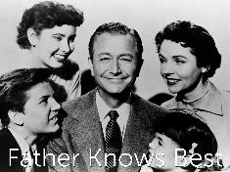but understanding father figure who was the bread winner and a supportive wife who took care of the home and kids. “Leave it to Beaver” from 1957 to 1963 was one of many shows which continued this tradition of showing what the nuclear family should be like into the 1960’s.

Between 1959 and 1973 an innocuous looking change occurred. Bonanza was the one of the hottest and longest running shows on TV. It portrayed a strong loving father in an old west family where the mother had died and he was the single parent. During this same time the Andy Griffith show portrayed this same single parent role positively. Also, between 1960 and 1972 you had the very popular “My Three Sons” where again the mother had died and kids are raised by a single parent with the help of an uncle. While these programs were for the most part positive and revealed some hard realities of life we must deal with, they, whether meaning to or not, challenged the need for the nuclear family unit of kids a mom and a pop. Notice in all of these the mother died, as America was not ready to deal with divorce in any positive way and at that time in the 50’s divorce was not prevalent.

The TV show “Family Affair” from 1966 to 1971 showed how an uncle and male butler could serve as parents without a mother when they take in the orphaned three children of his now dead brother. A 1963 movie and a TV show running from 1969 to 1972 called the “The Courtship of Eddie’s Father” also exemplified a widower being the single parent for a boy.

Now, take note that in the background of all of this, America is changing off the TV screen as well. The launch of the “Sputnik” satellite by the Russians in October of 1957 scared America into making drastic changes in its educational systems which will have effects which mushroom over time. In response to Sputnik and the perception that our Christian biases have kept us back in science, science textbooks will balloon in their treatment of evolutionary teaching between 1959 and 1963 from books in 1959 which contain only about 2000 to 3000 words on the theory of evolution to 1963 when the average science text then devoted over 33,000 words to teaching evolution. Not coincidentally, from the date of these inclusions of huge increases in evolutionary teachings in America’s science classes, we also see huge rises in divorce, violent crimes, sexual promiscuity in 10- to 14-year old’s, and abortions.

Following 1960’s court decisions barring prayer and Bible reading from the public schools, we see a 100% rise in divorce rates, drug use increased in America by 500%, violent crime increased 350%, standardized test scores dropped for 18 straight years, premarital sex exploded by 1000%, and suicide increased by 250% (from “America: to Pray? Or Not to Pray? Pages 4-106). When you tell Johnny he is just an animal, don’t be surprised when he acts like one. Further, when you tell people there is no God, no direction for their life and no hope for a future in eternity, don’t be surprised when they make wildly different choices than before. Such is the back drop which ushered in the rebelliousness of the 1960’s.

We take on more step away from the nuclear family ideal in the TV show “the Partridge Family” shown on TV from 1970 to 1974. This time it is the mother who is widowed and the single parent raising a large family. Additionally, however she is in the very nontraditional roles of a performer, breadwinner and working her kids in a musical group. Note, while none of these shows looks particularly problematic, they stretch the distance from the ideal of the nuclear family and change the societal roles for all family members.

The 1980’s shows a new shift away from the nuclear family as a host of programs will follow depicting single parent women from divorces raising their families and leading a household. The first of these will be “Who’s the Boss?” and “Kate and Allie” followed by “Grace”, “Gilmour Girls”, “Desperate Housewives”, “Reba” and many more which showed divorced women as the head of households who struggle, but successfully raise their kids. On daytime television “All of My Children’s” character of Erica Kane will go through 11 divorces over two decades and is portrayed as a role model.

From 1994 to 2004, the wildly popular “Friends” TV program showed how a bunch of friends could interact together, have relations without marriage and how the character Rachel had a baby outside of marriage with a friend and it supposedly all worked out well.

First lady Hillary Clinton’s book “It Takes a Village” underscores America’s transition away from a devotion to the nuclear family ideal and acceptance of just about anything goes.

Note how in a three-decade period, America via the very powerful medium of television is molded from a country that revered and modeled the nuclear family as the ideal goal, to an America where today the nuclear family is almost looked on as abnormal. Further, the molding of our minds by the media has progressed to the point that if someone now espouses the nuclear family as better, they are now labeled as ignorant and biased.

Now, how and why did this all happen? In the 1930’s, ‘40’s and ‘50’s Hollywood served as the showcase for American values and culture. For generations hard work, fair play and even religious fervor permeated the screens of movies and on TV. It was good business to give the people what they wanted and the Motion Picture Association of America (MPAA) guidelines set up to keep Hollywood out of trouble with Congress and the courts espoused these traditional values. The MPAA Code of 1930 incorporated many rules of what to do and not do in the movies. The code prohibited inclusion of "scenes of passion" unless they were essential to a film's plot, "pointed profanity" in either word or action, "sex perversion", justification or explicit coverage of adultery, sympathetic treatment of crime or criminals, dancing with "indecent" moves, and white slavery. Note that even the married couple the Petry’s on the Dick Van Dyke show (1961- 1966) slept in separate beds as to not violate these guidelines. This system will be well followed by the movie and TV industries until it falls apart in the mid 1960’s.

This falling away from these standards happened for many reasons. There was a change in leadership at the MPAA, there were pressures from competing foreign films which did not adhere to such standards, but perhaps the biggest was a social change in Hollywood. Long time film critic Michael Medved explains that in the 1960’s, Hollywood was invaded by a large amount of what he called the Marxist Ivy league elite who did not share American values. From this time, Hollywood no longer would reflect the religious, patriotic and political views of mainline America. Hollywood since this point has been dominated by a cynical, nihilistic (life has no meaning) cultural elite who despises religion in general and the Catholic Church in particular for its long opposition to the secular virtues of fornication, adultery, divorce, 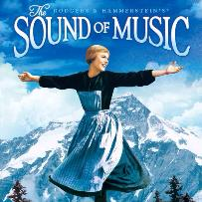abortion and homosexuality.

A grand example of this is the 1965 Best picture by the MPAA was the uplifting “The Sound of Music.” By 1969 however, best picture went to the bawdy tale “Midnight Cowboy” which had an “X” rating. This onslaught on American values was not limited to the movies however. From 1971 – 1979 TV was dominated by the highly popular “All in the Family” sitcom which portrayed lead character “Archie Bunker” as representing passé American values. Issues such as racism, homosexuality, women’s liberation, rape, religion, abortion, the Vietnam War, menopause and impotence were all discussed for the first time on network television, but always with a liberal spin which told America that the old religious right was wrong in almost every way.

Another example of this type of manipulation of our minds can be seen on the highly popular “Law and Order” series which ran from 1990 to 2010. Their 1991 show, “God Bless the Child” vilified and prosecuted “Christians” for believing in prayer above modern medicine. The 1992 episode “Sisters of Mercy” cast aspersions on the Catholic Church as it prosecuted a priest who molested a nun. Multiple episodes over their 20 year run of Law and Order portrayed anti-abortionist as crazy criminal zealots, dangerous to society. One of the most telling for our ministry was the 2007 episode of “Good Faith”, in which a father was portrayed as a crazy religious zealot for killing a teacher who taught evolution to his daughter in science class.

From the 1970’s through to today, TV has made a point of casting homosexual characters as positive people and role models and cast them in about 15% of all character roles. These depictions lied to the public and disingenuously molded public opinion in two ways. First, the percentage of gays on TV and movies is intentionally misleading to try and make them look like just a normal part of our society. The actual number of gays in America is about 2%. Second, the portrayal of gays as almost always positive contributors to society is a great misnomer. Apart from the multiple biblical prohibitions in the Bible against homosexuality, gays are statistically 500% more likely to be convicted of criminal activity and incarcerated than the rest of society. Further this “alternative life style” being pushed on us by the media is an unproductive one for society. Because of the natural cycles of birth and death, society must replenish itself and homosexuality does not lead to that, which is why it is so opposed in Russia where they need large amounts of births to populate and control a large land mass.

The molding of our minds by the media with their liberal mind sets continues today. This year in 2016 the popular TV show “Rissolli and Isles” portrayed the doctor on the show saying, “I am a doctor, I cannot believe (in God).” That not only puts forth the lie that any educated person cannot believe in God or have religious faith, but ignores the large proportion of medical doctors who have deep faith.

The Catholic Church is under massive attack today from multiple shows which depict priests as pedophiles and the church as protective of them. The very popular current show “Blue Bloods” depicts a supposedly devout Catholic family, but the media is unashamedly trying to mold Catholicism to Hollywood’s new image of morality. It depicts three adult members of this show’s devout Catholics having affairs and extramarital sex. It also portrays enlightened Catholics as people who appreciate homosexuals as good normal people to be accepted and valued by society. It even portrayed a good Catholic Nun as a lesbian.

We will be bombarded this season on “Madam Secretary” by a character not so subtly crafted to make us ready to vote for a woman as president, who not so coincidentally was our secretary of state. But this year a central theme of this show will be to preach to all viewers that global warming is the prevalent problem of our time and that all discussion about its scientific basis must be dismissed out of hand. Such is the molding of our minds which is ahead of us.

Teenage Mutant Ninja turtles, X-men, Marvel Agents of Shield, Spiderman and many more movies and TV shows advertise to our next generations that mutations are good and all creation can occur by accident without a God. The fact that both of these are scientifically false assumptions is never addressed. Further popular science fiction such as Star trek, Star Wars, Stargate SG1 and many more portray a universe where life is everywhere because it is natural and evolves everywhere without God. In the TV and movies from the 40’s and 50’s you would not have seen a science fiction movie which did not have reference for the Creator as exemplified in the classic “War of the Worlds” where it is credited as God’s provision that the Martians are killed. This is not so today.

The current fad of “Pokémon Go” even has an evolve button on it which teaches kids from age 2 that everything evolves and God is not necessary.

News organizations used to pride themselves in showing no bias when reporting a story. Famed newsmen such as Edward R. Murrow, Walter Cronkite, David Huntley and Chet Brinkley were noted for their professionalism and the ability not to show favoritism in reporting a story. Today, 90% of all news media show a marked liberal bias supporting the anti-conservative values of the Hollywood elite. It is also interesting to note that only 1.3% of the shows called “Christmas shows” at that time of year will actually mention God or Christ!

[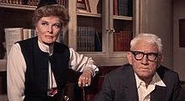](https://en.wikipedia.org/wiki/File:Hepburn_tracy_guess_whos_coming_to_dinner.jpg)Now, some will argue that it was not the media programming which caused the shifts in American culture, but that the content of the shows cited merely followed the shifts already occurring in American culture. That seems a reasonable premise, but the data does not bear it out. The explosion in violent crime, teen pregnancy and teen sexual promiscuity followed the insertion of more evolution into our educational curricula, these did not precede it. Some positive change spurred on by Hollywood is exemplified in the movie “Guess Who’s Coming to Dinner” with Spenser Tracy and Katherine Hepburn portraying two parents caught in a drama where their white daughter wants to marry an accomplished black man was filmed during a time in 1966 and 1967 when it was still illegal in 17 states for such a marriage to occur. The change in attitudes on this subject in America came after this film was released and after a Supreme Court ruling invalidated laws in those 17 states barring racial intermarriage.

Katherine Hepburn and Spencer Tracy

It was only after two decades of most TV programming and movies showed living together outside of marriage as the “new norm” that it actually started to materialize in American society. Today, the Catholic Church in the world, in America and in the vast majority of its membership in America stand firmly against infidelity, sex outside of marriage, abortion, and homosexuality, but as we have shown with our example of the popular program Blue Bloods, the writers and producers of that program are now trying to mold Catholic theology to their more liberal liking.

Many Americans today do not recognize America today as the country they grew up in, and marvel at how it seemed to change overnight. In fact, this has been a long process in which our courts and education process has been changing for a period of 150 years and our modern media has been molding our minds toward a liberal agenda for the last six decades. Today we are just seeing the fruits of all that liberal agenda coming to fruition in America today. But, what can we do about it?

First, we must pray that America will turn from its wicked ways and turn back to God. God has promised in the book of II Chronicles that if we will do that, “He will hear our prayers and heal our land.” We must also be evangelists for God, pointing out to people how coordinated has been this shift of America away from our traditional Judeo -Christian values and how we so greatly need to return to them. That is what the Tea Party movement is trying to do among other things today. Third, we must be super evaluative of the movies and programming we and our kids watch and vigilante to recognize how the liberal media is trying to mold our values to a new elitist and godless norm. Our churches must lead the way in standing firm against the attempts to make all of Christianity to compromise its theology to the new norms and thereby making all such churches useless. To do all of this will require much prayer and God’s Spirit to direct us through a very different America than we have ever seen before. It is only with God’s strength and direction that we can navigate through such waters. Further, it will ask all of us to step out and stand up for God’s values with a renewed reverence for biblical values if this tide is to be turned in any meaningful way.

____________________________________________________________________________________

**Harvard's 'Smart' Theory about Human Intelligence**

By Bill Hoffmann   |   Wednesday, 03 Aug 2016 05:32 PM Harvard’s Newsmax.com

A new study by Harvard University suggests humans are likely the first intelligent species to develop in the vast cosmos — and we will continue to grow more so in the future.

"The universe is 13.8 billion years old, while our planet formed just 4.5 billion years ago. Some scientists think this time gap means that life on other planets could be billions of years older than ours," the Harvard-Smithsonian Center for Astrophysics said in a statement.

"However, new theoretical work suggests that present-day life is actually premature from a cosmic perspective." Avi Loeb, lead author of the study added: "If you ask, 'When is life most likely to emerge?' you might naively say, 'Now.' But we find that the chance of life grows much higher in the distant future."

According to the study, life as we know it first "became possible about 30 million years after the Big Bang, when the first stars seeded the cosmos with the necessary elements like carbon and oxygen." As well, life will end 10 trillion years from now when the last stars fade away and die. Loeb and his colleagues considered the relative likelihood of life between those two boundaries. The dominant factor proved to be the lifetimes of stars.

The higher a star's mass, the shorter its lifetime. Stars larger than about three times the sun's mass will expire before life has a chance to evolve. Conversely, the smallest stars weigh less than 10 percent as much as the Sun, according to the study.

They will glow for 10 trillion years, giving life ample time to emerge on any planets they host. As a result, the probability of life grows over time. In fact, Loeb said, chances of life are 1,000 times higher in the distant future than now.

"So then you may ask, why aren't we living in the future next to a low-mass star?" he asked. "One possibility is we're premature. Another possibility is that the environment around a low-mass star is hazardous to life."

Although low-mass, red dwarf stars live for a long time, they also pose unique threats. In their youth they emit strong flares and ultraviolet radiation that could strip the atmosphere from any rocky world in the habitable zone, according to Loeb.

To determine which possibility is correct — our premature existence or the hazard of low-mass stars — Loeb recommended studying nearby red dwarf stars and their planets for signs of habitability. Future space missions like the Transiting Exoplanet Survey Satellite and James Webb Space Telescope should help to answer these questions, the Harvard Study notes.

Breaking News at Newsmax.com <http://www.newsmax.com/US/harvard-intelligence-human-galaxy/2016/08/03/id/742027/#ixzz4GPvhzpMH>

**Editor’s Note: The theory of evolution predicts that life can occur spontaneously wherever water and certain other physical conditions exist. Thus, if evolution is true, we should find life everywhere in the cosmos, but we do not. We have been searching via radio telescopes for decades and found nothing. The author of this piece, as well as the scientists interviewed are so steeped into the religion of evolution, that they continue to search for answers only in that religious framework, and miss the obvious conclusion from this evidence. What the evidence affirms is that the theory of evolution is wrong and, as the Bible describes, life is only specially designed for this cradle we call Earth and by an intelligent Creator. Life does not haphazardly create itself out of natural chemistry, but only occurs when an intelligent Creator crafts it and puts it there. These people totally miss the implications of all this research by starting with wrong assumptions about nature. They have eliminated the Creator as being a possibility, and thus completely overlook direct evidence of His existence!**

**Try this Great Creationist Website!**

If you would like to see a wealth of creation science materials at a new website, try the **Genesis Apologetics** website at <http://genesisapologetics.com/debunking-evolution-series>

Genesis ApologeticsThe website includes sections with materials which will answer questions middle schoolers and high schoolers have about evolution and creation. This is a site which can be invaluable to both parents of kids in public schools, as well as for home schoolers. In addition to a wealth of other materials on this website, you can use the link above to view a series of 10-20 minute vignettes featuring 2 high school to college age young people who explore various problems with evolution as taught in our schools. We may well feature some of these vignettes at future SABBSA meetings. Check these videos out and browse this cool website if you have the time.

**SABBSA on KSLR**

Please join the San **Antonio Bible Based Science Association** as we are now “on the air” each Saturday afternoon with “**Believing the Bible!”** Join us **Saturday afternoons at 1:45 pm on radio station KSLR 630 AM**.

Here is our schedule of program topics for this fall:

Oct 8   -  **Age of the Earth**

Oct 15 -  **Test tube Life**

Oct 22 -  **Life from Outer Space**

Oct 29 -  **Age of the Universe**

Nov 5 -  **Why we do this**

Nov 12 - **Apeman**

Nov 19 - **Feathered Dinosaurs**

Nov 26 -  **The Geologic Column**

There are several ways you can help with this exciting new endeavor. One and always first is pray for this program, for its content, its producers and impact. Second, become a sponsor, as many of our board members have done and help us defray the $60+ per week costs of putting this program on the air. Third listen to this show on the air and tell your friends and family members, so this can reach as wide an audience as possible. Fourth, help us with scripts. We are hoping that our board and other interested and knowledgeable members will both tell us what they would like to hear in future programs as well as help us by writing future scripts and coming on the air with us to make this truly a group effort.

Also, we now have an opportunity to take this program and broadcast it in radio stations across the country. To do that though we need sponsors to underwrite it at the very modest cost of $303 per month. Contact us at 210-861-0454 if you would like to help and expand our ministry in this way.

This program is available on podcast. If you cannot tune in on Saturday afternoons, or would like to sample our program or hear previous shows, they are available on podcast on the KSLR website. Click on the link below to go to the KSLR podcast page and scroll down till you find "Believing the Bible."

["Believing the Bible" - SABBSA on KSLR Radio](http://kslr.com/podcasts)

Please join us each Saturday at 1:45 pm on radio KSLR 630 AM for **“Believing the Bible.**

**Science Workshops at FEAST in Fall 2016 **

SABBSA president **Scott Lane** will present selected portions of his creation series to audiences at the FEAST Science Workshops in 2016 and 2017. All presentations will be at 6:30 pm on the fourth Monday's of each month. A companion young children's "hands on" program is also provided each night. The fall schedule is shown below:

September - **"The DeFaithing of America"** - This multimedia presentation gives participants an understanding of how two societal shifts played out in America over the past century. How did we go from a nation where in 1925 it was illegal to teach evolution in public schools to today where it is illegal to teach God's creation in schools? Parallel to this phenomenon another societal shift was happening. America was undergoing a systematic move to eliminate God from all phases of our society. How did that occur? We examine that parallel societal shift as well.

October - **"Introduction to Creation Theories"** - this presentation covers the full continuum of theories between evolution and creation. It includes capsules on the compromise theories of scientific creationism, gap theory, day/age theory, intelligent design, progressive creationism, and theistic evolution. It sets the stage for all further presentations.

**Prayer Needs and Praises!**

**SABBSA** for prayer, support and guidance as we consider expanding our radio ministry.

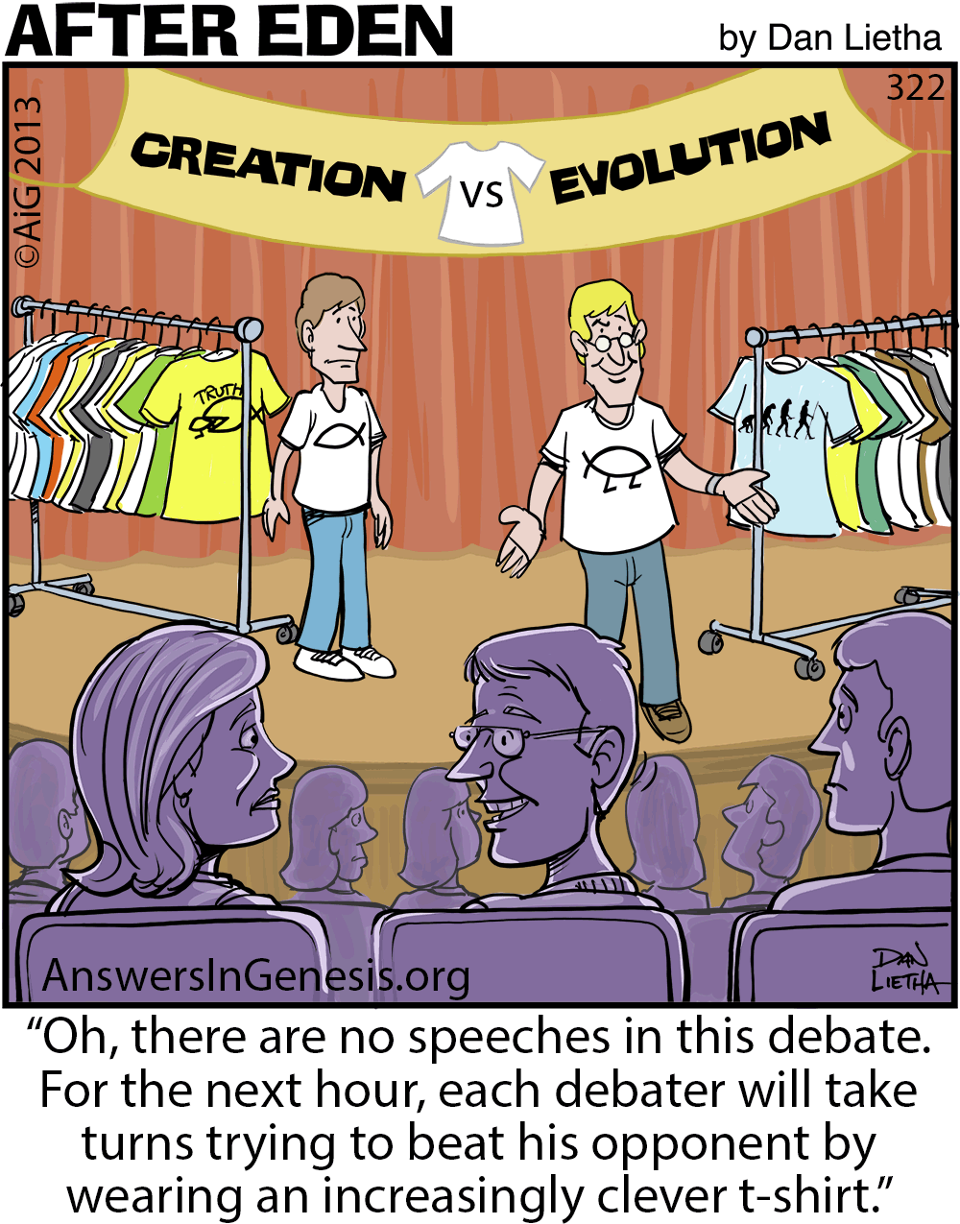

**Humor Corner**

**Around Texas**

**Houston:**   
The **Greater Houston Creation Association** (**GHCA**) meets the first Thursday of each month. They meet at Houston's First Baptist Church at 7 pm, in Room 143. After the presentation, there will be refreshments, fellowship and creation science materials for all to enjoy. They are currently in the midst of a seven-month series of teachings. Their meetings can be streamed live! For more information, go to [www.ghcaonline.com](http://r20.rs6.net/tn.jsp?llr=bztaencab&et=1103662222545&s=545&e=001xF-6WOYzM5Yyre44Ea_qUjH5EOT_fFIGjrfpfa5h-rD53IlUVbz3Vc0Dp47_VEwW3iQQ6F1b6K0EtKc_vUxYKpzN_8V2upXFbsOScvUeD92nJdUTjDIFeg==).

**Glen Rose:**   
Dr. Carl Baugh gives a “***Director’s Lecture Series***” on the first Saturday of each month at the Creation Evidences Museum just outside Glen Rose, TX. The new and improved museum is also a great and beneficial way to spend any day. Presentations are at 11 am and 2 pm. For more information, go to [www.creationevidence.org](http://www.creationevidence.org)

**Dallas-Ft Worth:**   
The Metroplex Institute of Origin Science (MIOS) meets at the Dr. Pepper Starcenter, 12700 N. Stemmons Fwy, Farmers Branch, TX, usually at 7:30 pm of the first Tuesday of each month.

**Lubbock Area (Crosbyton):**   
All year: Consider a visit to the Mt. Blanco Fossil Museum, directed by Joe Taylor. The Museum is definitely worth the visit if you live near or are traveling through the Panhandle near Lubbock. If you call ahead and time permitting, Joe has been known to give personal tours, especially to groups. For more information, visit [http://www.mtblanco.com/](http://r20.rs6.net/tn.jsp?llr=bztaencab&et=1103662222545&s=545&e=001xF-6WOYzM5bqqt6T1G_CwJWJosrOSIhLAagtnP0Z504J-gEROEBe22S3gq720x6ofjFVqK-AfJcsjrsuQyRtoepYiAQVVUFC-cF56fLwwBJ0SQ-44KlLmw==).

**Greater San Antonio area:** Listen to **Answers with Ken Ham** online at the address below. (No nearby station for this broadcast). <http://www.answersingenesis.org/media/audio/answers-daily> To hear program from the **Institute for Creation Research**, listen online at this address. <http://www.icr.org/radio/>Also, tune in KHCB FM 88.5 (San Marcos) or KKER FM 88.7 (Kerrville) for **Back to Genesis** at 8:57 AM Mon-Fri, then **Science, Scripture and Salvation** at 1:30 AM, 8:00 AM and 4:30 PM on Saturdays.

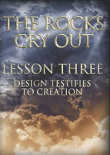

**Last Month at SABBSA**

**"The Rocks Cry Out" Lesson 3 - Design Testifies to Creation**

In September we continued "**Search for the Truth Ministries**" newest DVD series called the **"Rocks Cry Out"**. We will continue that series through the fall.

This is not just a class on the evidence for creation. The goal of this study is to increase participants trust in the reliability and accuracy of God's Word.

Lesson 3 asked the question, "How can we know if design is the result of natural processes or intelligence?" This lesson traveled from Pictured Rocks National Lakeshore to the Badland National park and Mt. Rushmore to show how the design of life testifies to God as its designer. We took a closer look at the supposed mechanisms driving evolution (mutations and natural selection) to show the impossibility of these forces driving life upward in complexity. While we were not overly impressed by the metaphors used, we were impressed by the evidence in nature which shows the Creator’s designs!

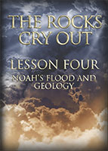

**Next SABBSA Meeting:   
Tuesday, October 11, 2016, at 7 pm**

**Coming to SABBSA in October**

**"The Rocks Cry Out" Lesson 4 - Noah's Flood and Geology**

We will continue with "**Search for the Truth Ministries'**" newest DVD series called the **"Rocks Cry Out"** through the fall which testifies to the reliability and accuracy of God's Word.

The starting assumption of modern geology is slow processes and lots of time to create the sedimentary rock layers of the Earth. Therefore, modern geologists cannot even consider the possibility of a world-covering flood which would have created these rock layers rapidly and recently. This lesson examines the Top 7 Evidences for the rapid deposition of the rock layers of the Earth and the implications of leaving this Biblical model out of our thinking.

Please join us in October for creation science and biblical apologetics teaching you will find nowhere else in Bexar County. As always, we will meet at the Jim’s Restaurant at the corner of San Pedro and Ramsey.