Communique'

President - Scott Lane 599-7240 Vice President – Al(den) Johnson, O.D.   
Secretary – Clarence Johnson Treasurer – Carl Williams, M.D.   
[website – [www.sabbsa.org](http://www.sabbsa.org) ] [P.O. Box 34478, San Antonio, TX 78265]

**November 2016**

Halloween has howled, an election nears and we are in hopes of winter weather soon. We at SABBSA hope you and yours are well and enjoying this changing season.

This **Communique newsletter** contains a lead article shows how little data scientists often use to make the largest of declarations. It also exemplifies how your worldview dictates what you see and how you interpret it. We have an article describing the findings of secular scientists which put another dagger into the heart of the failing dark matter theory which is needed to prop up the failing Big Bang theory on which much of universal evolution theories rest. We also have an article on the discovery of the first soft dinosaur brain tissue, which when correctly interpreted gives sizeable evidence for a recent creation. Finally, we have some good news on Mark Armitage who was fired for publishing his discoveries on soft tissues in a triceratops horn.

Of course, we also have a rundown of all the creation science happenings in the greater San Antonio area. We hope you are informed and edified by this newsletter.

**Do Beardogs Show Evolution or Variation?**

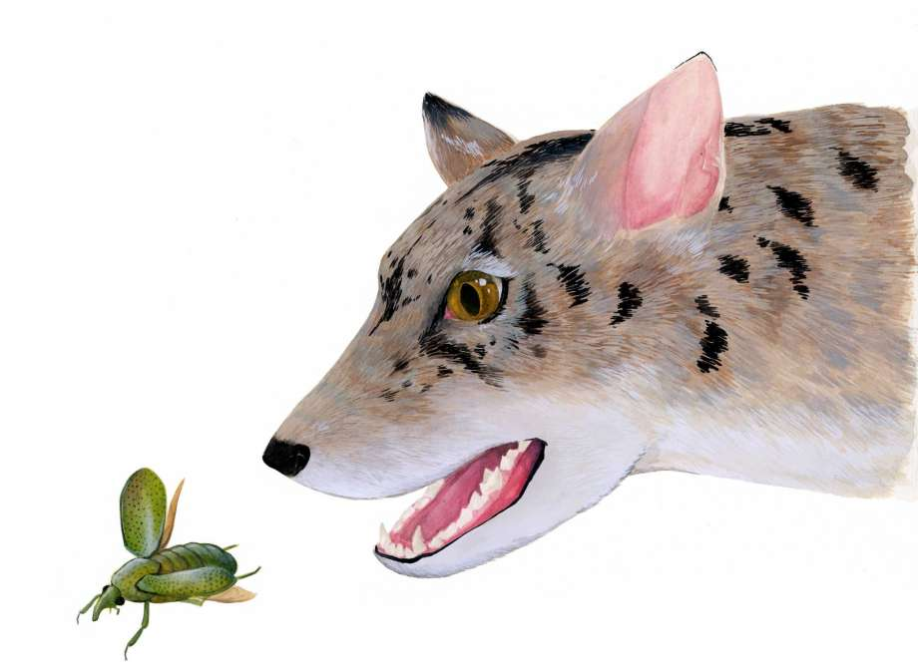Excerpts from CBS News, AP and Chicago Tribune stories.

For decades, a fossilized carnivore jawbone sat largely unnoticed in a drawer at Chicago's Field Museum.

Now the scientist who grew curious when he opened that drawer has established with a colleague that the fossil belonged to an early, long-extinct relative of dogs, foxes and weasels known as a beardog. The Field Museum fossil and another at the University of Texas each represent a new genus, the taxonomic rank above species.

The researchers believe these beardogs, which lived up to 40 million years ago, may eventually tell the world more about the evolution of dogs and other carnivores and how animals adapt to changes in climate.

According to a paper to be published Wednesday in the journal Royal Society Open Science, the jawbones belonged to two closely related types of Chihuahua-sized beardogs, new genera now named Gustafsonia and Angelarctocyon…

The fossil was discovered in Texas in 1946 and 30 years ago was loosely classified as some type of carnivore. But no one knew where it fit into the carnivore family, said Susumu Tomiya, who authored the paper with Jack Tseng of the State University of New York at Buffalo.

The teeth stood out to Tomiya who works at the field museum. They had flatter surfaces for crushing that suggested their owners ate more than meat — maybe berries and bugs, too, like present-day foxes. The teeth reminded Tomiya of beardogs he was familiar with, he said. But the types of beardogs he knew were much larger predators that were the size of a bear and once roamed parts of North America, Europe, Asia and Africa.

The researchers also compared the fossil with one written about in an earlier paper at the University of Texas. Tomiya and Tseng concluded both belonged in what had essentially been a blank spot in the branch of the mammalian tree that includes dogs, raccoons, weasels and similar animals. Beardogs evolved alongside the ancient cousins of present-day dogs, cats, bears and other carnivores. 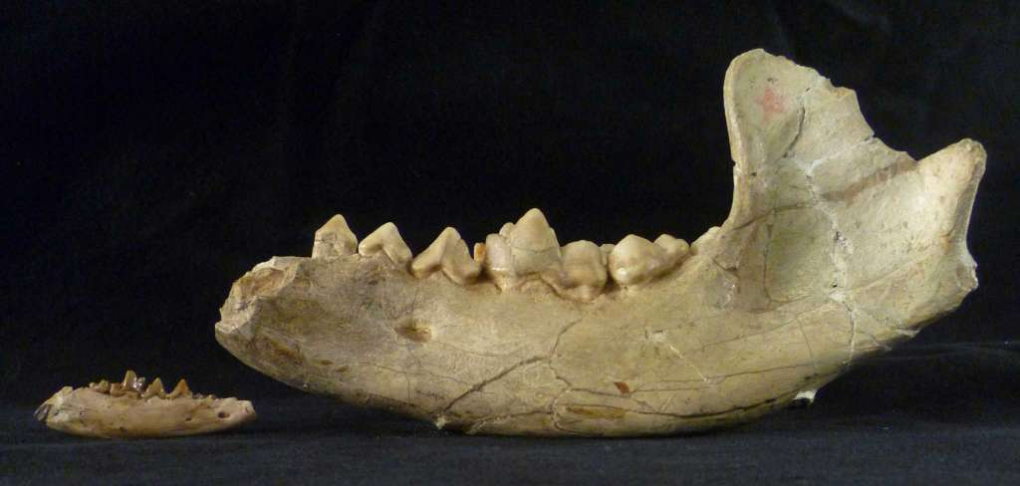

The evolution of beardogs from the small varieties classified by Tomiya and Tseng to the much larger animals that needed more food and habitat seems to match evolutionary paths of other animals that led to extinction, Tomiya said. Beardogs were extinct by 5 million to 10 million years ago, he said.

Studying how the diversity of beardogs waxed and waned over time could tell us about larger patterns in carnivore evolution," he said. The two genera of small beardogs also lived at a time of climate transition in North America, from subtropical to cooler and relatively dry. Further study could help answer questions about what kinds of animals adapted well to that change, Tomiya said…

**Editor’s Note: You can see from the second picture how little fossilized evidence all of these conjectures about this being an ancestor of dogs and the like is all dreamed up from. Note that when this was found thirty years ago, the paleontologists who found it were much more honest in their evaluation of what it was, rather than the bold statements made in this new paper. Even the conjectures about it being a carnivore are shaky since we have found canine teeth in many living animals today which are strict herbivores such as the Panda, and Spider Monkey.**

**The forty-million-year dating is due to the rock strata it was found in and the radiometric process used to give that date has been proven 100% fallible. Rather than this being an unevolved ancestor of dogs, this could easily be a simple variation on the dog/wolf kind. The evidence plays both ways. Your conclusion about this find depends on your worldview.**

**Spinning Galaxies Question Existence of Dark Matter**

By Kacey Deamer Livescience.com October 27, 2016

**Some 80 years after dark matter was first theorized,** we [still have no idea](https://cosmosmagazine.com/physics/the-dark-side-of-the-universe-a-primer) what it is. Now, a new study casts doubt on its existence altogether.

According to the standard model of cosmology, the immense gravity of dark matter is crucial for explaining why galaxies can spin so fast without tearing themselves apart. But in work just accepted by *Physical Review Letters*, a team of American astronomers found a striking correlation between the visible matter (the stars and dust in galaxies) and its rotation speed. That means they can predict the rotation of galaxies – without invoking the dark stuff at all.

[The problem with dark matter](https://cosmosmagazine.com/physics/problem-dark-matter)

“Nothing in the standard cosmological model predicts this and it is almost impossible to imagine how that model could be modified to explain it, without discarding the dark matter hypothesis completely,” said David Merritt, an astrophysicist at Rochester Institute of Technology in New York and who was not involved in the research.

Gravity at the level of the solar system is a piece of cake. Simple laws, written by Johannes Kepler in the 1600s, tell us that a planet’s orbital speed depends precisely on its distance from the sun. So, while Mercury whizzes around the sun at an average of 47 kilometers per second, Pluto shuffles along at just a 10th that speed.

The weird thing is, galaxies don’t behave this way at all – stars don’t slow the further they are from the galactic center. In some cases, they speed up. According to our current understanding of gravity, stars at the edges of galaxies, such as our sun, should be flung out into deep space. (this also leads to the winding problem showing that galaxies should not be in such perfect spirals if they have existed for billions of years, but they appear newly created?)

In the 1970s the American astronomer Vera Rubin, picking up an idea pitched by Swiss astronomer Franz Zwicky a few decades before, suggested an answer: there must be extra matter in and around the galaxies – perhaps 10 times more than what we can see – holding everything together. But after 40 years of fruitless searching, some physicists think the hunt for dark matter has been a wild goose chase.

[Ghost traps: the hunt for dark matter](https://cosmosmagazine.com/physics/ghost-traps-hunt-dark-matter)

In the new work, a team led by Stacy McGaugh at Case Western University in Ohio found a direct relationship between the distribution of regular matter in a galaxy and its speed of rotation. This distribution held, even for galaxies thought to be dominated by dark matter.

McGaugh’s team pored over data from 153 galaxies collected by NASA’s Spitzer Space Telescope. Imaging in the infrared, Spitzer can see both the stars and the immense clouds of dust between them – and these components allowed McGaugh’s team to calculate the mass of the visible matter in each galaxy more accurately than ever before.

Then they compared these masses against the actual rotation speeds of each galaxy, which were clocked by astronomers for decades. Surprisingly, for dark matter advocates at least, the measurements showed a tight correlation. This means the team could look at a galaxy’s visible matter and predict its rate of spin. The relationship is strong enough to be termed a new law of nature, “a sort of Kepler's law for rotating galaxies,” the authors write.

The result was consistent over 2,693 data points across 153 galaxies with a huge variation in body shape – from dwarfs to giants, from spiral-armed or irregular beasts, some with central bulges and others without – all without accounting for dark matter. The question is, why?

Perhaps our understanding of gravity is fundamentally wrong. One theory waiting in the wings is modified Newtonian dynamics which says that gravity behaves differently at very large distances. It has been successfully applied to galaxy rotation as well.

**Editor’s Note: For those who don’t know Dark Matter, it is an unobserved and undefined type of invisible matter which is supposed to make up most of our universe. It is a “fudge factor” invented by physicists since galaxies did not behave according to standard Newtonian physics. It is an unobserved, theorized and wholly unproven phenomena upon which the current Big Bang cosmology rests. Now we have evidence from secular astronomers showing again that it does not exist and that the theories on the Big Bang and universal evolution may be 100% wrong.**

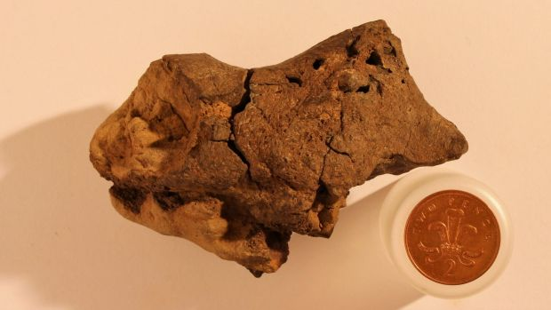**First-ever dinosaur brain tissue found**

Photograph shows what scientists have identified as the first known example of fossilized brain tissue from a dinosaur (shown next to a coin for size comparison). Jamie Hiscocks, University of Cambridge via REUTERS

What was going on in dinosaurs’ noggins? … Paleontologists may never know,,,,, but they just got one step closer with the first-ever discovery of brain tissue from a dinosaur. And it’s tiny.

The brainy finding looked like an unassuming brown pebble when a fossil hunter in Sussex, England, found it more than a decade ago. Discovering any soft tissue from a dinosaur is rare since that material degrades faster than other types of tissue, and dinosaurs [supposedly] lived more than 66 million years ago. (Editor’s note: Not that rare, we find them all the time now debunking the idea of long ages.)

This particular soft tissue was essentially pickled when the dinosaur died, according to the researchers, which is why it was so well-preserved. “What we think happened is that this particular dinosaur died in or near a body of water, and its head ended up partially buried in the sediment at the bottom,” co-author David Norman, a scientist at the University of Cambridge, said in a statement. “Since the water had little oxygen and was very acidic, the soft tissues of the brain were likely preserved and cast before the rest of its body was buried in the sediment.”

Using a scanning electron microscope (SEM) — which produces images in fine detail by moving a beam of electrons over an object — the researchers identified different structures within the pebble-size tissue. In the images, they could make out meninges (tissue that surrounds the brain), strands of collagen and blood vessels, and structures that could be from the brain’s cortex (the outer layer of the brain).

Norman and his colleagues determined the brain tissue was likely from a species similar to Iguanodon, a large herbivorous dinosaur …

“It was indeed structured rather like that seen typically in reptiles,” Norman told Live Science. “It also does not show that dinosaurs were necessarily very smart — their brains did not fill their braincases in this instance.”

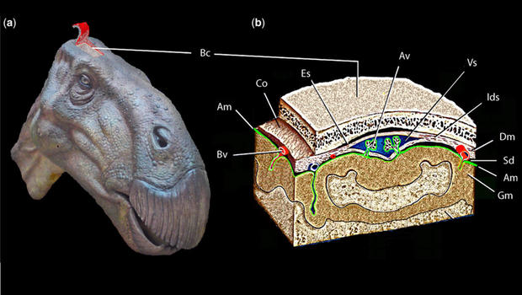(a) Reconstruction of the head showing the area of the skull roof that has been ‘dissected’ to the right. (b) Partly ‘exploded’ restoration of the underlying braincase and brain tissues identified following detailed examination of the structures preserved in the natural cranial endocast. Am, arachnoid mater (meninge); Av, arachnoid villus (protruding into a mid-line venous sinus); Bc, braincase bone (parietal); Bv, blood vessels; Co, collagenous sheath enclosing the brain structures and lining the bones of braincase (combined periosteal and meningeal sheets); Dm, dura mater (meninge); Es, epidural space; Gm, grey matter (brain cortex); Ids, intradural space (between the meninges); Sd, subdural space; Vs, sagittal venous sinus. University of Cambridge

In reptiles, and assumed for dinosaurs, the brain only takes up about half of the space within the cranial cavity. The rest of the space is a dense region of blood vessels that surrounds the brain. Based on the structures seen in the fossilized brain, the researchers said it is consistent with reptiles. Though some dinosaurs are believed to have sported quite large brains, namely those that led to modern birds, Norman said this particular fossil does not display such size.

The researchers also cautioned against drawing conclusions about the intelligence of dinosaurs from this fossil. However, they do posit that this dinosaur and its relatives had relatively complex behaviors. “It is reasonable to suppose that iguanodontian dinosaurs of this type were moderately complex behaviorally (no less so than modern crocodilians, for example),” the researchers wrote.

Their findings were published Oct. 27 in a Special Publication of the Geological Society of London.

This is an excerpted story. Full story at [www.cbsnews.com/news/dinosaur-brain-fossilized-ssue-found-researchers-say/](http://www.cbsnews.com/news/dinosaur-brain-fossilized-ssue-found-researchers-say/)

**Editor’s Note: Note that all the evidence shown by this brain point to a typical reptilian brain for dinosaurs. Not the bird connection paleontologist now wish to fantasize about. The explanation for how this brain was “pickled” and thus preserved is very questionable, but they had to come up with something, because if there is not such a crazy answer as the one they offered, it means this soft tissue gives clear evidence of this brain tissue being very young and their worldview will not allow them to even entertain such thoughts. In truth, this find is excellent evidence for dinosaurs not being bird evolutionary relatives and for them having lived very recently. Both findings fit well within the creationist framework and not evolution.**

# http://www.breakingchristiannews.com/images/news/triceratops-skull-240.jpg**Christian Biologist Fired for Questioning Evolution Receives Six-Figure Financial Settlement**

**By** [**Suzette Gutierrez-Cachila**](http://www.gospelherald.com/reporter/suzette-gutierrez-cachila) **(**[**news@gospelherald.com**](mailto:news@gospelherald.com)**)**

Christian scientist who was fired by the school he worked for after discovering evidence that could challenge evolution was granted a hefty financial settlement for his lawsuit.

Mark Armitage, who managed the electron microscope laboratory at California State University Northridge, made a surprising discovery in 2012 after unearthing triceratops horns at the Hell Creek Formation. Upon returning to his lab, he examined the horns and found soft tissue preserved along with the fossil.

“They were brown, stretchy sheets. I was shocked to see anything that was that pliable,” he described. The discovery was significant because it indicated that the specimen was from around 4,000 years ago, during the time of the great flood, and not 60 million years ago as evolutionists argued. He wrote a paper about his findings, which was published in the peer-reviewed journal Acta Histochemica. However, two weeks after his paper was published, he was surprised to find that the school terminated his employment.

He feared he was fired because the evolutionists in his department could not accept his findings.

“We will not tolerate your religion in this department!” his supervisor reportedly told him.

Armitage said he did not even made conclusions in his paper except that the case needed further investigation. He did not include his personal views in the paper. Paleontologist Mary Schweitzer, who reviewed the paper before publication, saw nothing wrong with it. “It was just morphology,” she said. “It was fine.” Schweitzer herself discovered soft tissue in dinosaur fossil in 2005.

In 2014, Armitage filed a lawsuit against CSUN through the Pacific Justice Institute. "Terminating an employee because of their religious views is completely inappropriate and illegal. But doing so in an attempt to silence scientific speech at a public university is even more alarming. This should be a wakeup call and warning to the entire world of academia," PJI president Brad Dacus said.

In September, CSUN settled the lawsuit and awarded Armitage an amount that could equal about 15 times his salary as former part-time staff at the school. Armitage’s lawyer Alan Reinach did not disclose the exact amount of the settlement. The school said that the financial settlement “is not an indication of any wrongdoing.” However, Reinach believed otherwise and said the school would not have been willing to give a large amount of money if it refused to admit that “we had them dead to rights.” “The state doesn’t put large, six-figure settlement money out unless they are really concerned they are going to lose,” he said.

**SABBSA on KSLR**

Please join the San **Antonio Bible Based Science Association** as we are now “on the air” each Saturday afternoon with “**Believing the Bible!”** Join us **Saturday afternoons at 1:45 pm on radio station KSLR 630 AM**.

Here is our schedule of program topics for this fall:

Nov 5 -  **Why we do this**

Nov 12 - **Ape-man**

Nov 19 - **Feathered Dinosaurs**

Nov 26 -  **The Geologic Column**

There are several ways you can help with this exciting new endeavor. One and always first is pray for this program, for its content, its producers and impact. Second, become a sponsor, as many of our board members have done and help us defray the $60+ per week costs of putting this program on the air. Third listen to this show on the air and tell your friends and family members, so this can reach as wide an audience as possible. Fourth, help us with scripts. We are hoping that our board and other interested and knowledgeable members will both tell us what they would like to hear in future programs as well as help us by writing future scripts and coming on the air with us to make this truly a group effort.

Also, we now have an opportunity to take this program and broadcast it in radio stations across the country. To do that though we need sponsors to underwrite it at the very modest cost of $303 per month. Contact us at 210-861-0454 if you would like to help and expand our ministry in this way.

This program is available on podcast. If you cannot tune in on Saturday afternoons, or would like to sample our program or hear previous shows, they are available on podcast on the KSLR website. Click on the link below to go to the KSLR podcast page and scroll down till you find "Believing the Bible."

["Believing the Bible" - SABBSA on KSLR Radio](http://kslr.com/podcasts)

Please join us each Saturday at 1:45 pm on radio KSLR 630 AM for **“Believing the Bible.**

**Evangelical Philosophical Apologetics Conference in November**

**Evangelical Philosophical Society Apologetics, 14th Annual Apologetics Conference** will be held at Trinity Baptist Church on Mulberry Street here in San Antonio, November 17-19, 2016. One breakout session at this conference which is mostly about theological apologetics is entitled "Evolution's Achilles' Heel:  How Naturalistic Science Digs Its Own Grave." For more information on this conference go to <http://epsapologetics.com/sessions/sessions.asp>

**Science Workshops at FEAST in Spring 2017 **

We thank all the many participants who attended the FEAST Science Workshops this fall. Our presentations of the **De-Faithing of America** and **Introduction to Creation Theories** were very well received.

SABBSA president **Scott Lane** will present four more multimedia creation science presentations as selected by our FEAST participants at the FEAST Science Workshops in 2017. All presentations will be at 6:30 pm on the fourth Monday's of each month. A companion young children's "hands on" program is also provided each night.

FEAST Science Workshops will take the next two months off for the holidays, but come the New Year we have a full complement of creation science programs selected by our FEAST science workshop participants. The schedule of programs is shown below:

January, 2017 - **Dinosaurs and the Bible**

February, 2017 - **The Discovery of Genesis in Chinese**

March, 2017 - **Distant Starlight, Big Bang and the Bible**

April, 2017 - **Where did Cain get his Wife and other Supposed Biblical Contradictions**

**SABBSA Schedule for Monthly Meetings in the Next Three Months**

All meetings at 7 pm at the Jim’s Restaurant at the corner of San Pedro and Ramsey.

November 8 **The Rocks Cry Out – Lesson 5 – Dinosaurs and Dragons**

December 13 **The Rocks Cry Out – Lesson 6 – Age of Creation**

January 10, 2017 **The Principle** (major theater documentary film)

**Prayer Needs and Praises!**

**SABBSA** for prayer, support and guidance as we consider expanding our radio ministry.



**Humor Corner**

**Around Texas**

**Houston:**   
The **Greater Houston Creation Association** (**GHCA**) meets the first Thursday of each month. They meet at Houston's First Baptist Church at 7 pm, in Room 143. After the presentation, there will be refreshments, fellowship and creation science materials for all to enjoy. They are currently in the midst of a seven-month series of teachings. Their meetings can be streamed live! For more information, go to [www.ghcaonline.com](http://r20.rs6.net/tn.jsp?llr=bztaencab&et=1103662222545&s=545&e=001xF-6WOYzM5Yyre44Ea_qUjH5EOT_fFIGjrfpfa5h-rD53IlUVbz3Vc0Dp47_VEwW3iQQ6F1b6K0EtKc_vUxYKpzN_8V2upXFbsOScvUeD92nJdUTjDIFeg==).

**Glen Rose:**   
Dr. Carl Baugh gives a “***Director’s Lecture Series***” on the first Saturday of each month at the Creation Evidences Museum just outside Glen Rose, TX. The new and improved museum is also a great and beneficial way to spend any day. Presentations are at 11 am and 2 pm. For more information, go to [www.creationevidence.org](http://www.creationevidence.org)

**Dallas-Ft Worth:**   
The Metroplex Institute of Origin Science (MIOS) meets at the Dr. Pepper Starcenter, 12700 N. Stemmons Fwy, Farmers Branch, TX, usually at 7:30 pm of the first Tuesday of each month.

**Lubbock Area (Crosbyton):**   
All year: Consider a visit to the Mt. Blanco Fossil Museum, directed by Joe Taylor. The Museum is definitely worth the visit if you live near or are traveling through the Panhandle near Lubbock. If you call ahead and time permitting, Joe has been known to give personal tours, especially to groups. For more information, visit [http://www.mtblanco.com/](http://r20.rs6.net/tn.jsp?llr=bztaencab&et=1103662222545&s=545&e=001xF-6WOYzM5bqqt6T1G_CwJWJosrOSIhLAagtnP0Z504J-gEROEBe22S3gq720x6ofjFVqK-AfJcsjrsuQyRtoepYiAQVVUFC-cF56fLwwBJ0SQ-44KlLmw==).

**Greater San Antonio area:** Listen to **Answers with Ken Ham** online at the address below. (No nearby station for this broadcast). <http://www.answersingenesis.org/media/audio/answers-daily> To hear program from the **Institute for Creation Research**, listen online at this address. <http://www.icr.org/radio/>Also, tune in KHCB FM 88.5 (San Marcos) or KKER FM 88.7 (Kerrville) for **Back to Genesis** at 8:57 AM Mon-Fri, then **Science, Scripture and Salvation** at 1:30 AM, 8:00 AM and 4:30 PM on Saturdays.



**Last Month at SABBSA**

**"The Rocks Cry Out" Lesson 4 - Noah's Flood and Geology**

In October, we continued "**Search for the Truth Ministries**" newest DVD series called the **"Rocks Cry Out"**. We will continue that series through the fall.

This is not just a class on the evidence for creation. The goal of this study is to increase participants’ trust in the reliability and accuracy of God's Word.

The starting assumption of modern geology is slow processes and lots of time to create the sedimentary rock layers of the Earth. Therefore, modern geologists cannot even consider the possibility of a world-covering flood which would have created these rock layers rapidly and recently. This lesson examined the Top 7 Evidences for the rapid deposition of the rock layers of the Earth and the implications of leaving this Biblical model out of our thinking. We found this to be a very well done and pointed indictment of contemporary geology and very supportive of the biblical timeline. We also previewed one episode of the "Debunking Evolution" video series from Genesis Apologetics and evaluated it to be a great tool for youth groups.

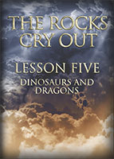**Next SABBSA Meeting:   
Tuesday, November 8, 2016 (Election Day) at 7 pm**

**Coming to SABBSA in November**

**"The Rocks Cry Out" Lesson 5 - Dinosaurs and Dragons**

We will continue with "**Search for the Truth Ministries'**" newest DVD series called the **"Rocks Cry Out"** through November and December.

Dinosaurs are used extensively to convince children that evolution is a fact and mankind evolved to appear upon the Earth millions of years AFTER dinosaurs went extinct. Yet cultures around the world and throughout history have references to these creatures. This lesson examines how dinosaurs fit into biblical history and reveals recent irrefutable discoveries confirming that dinosaurs were created quite recently - right alongside mankind.

Please join us in November for creation science and biblical apologetics teaching you will find nowhere else in Bexar County. As always, we will meet at the Jim’s Restaurant at the corner of San Pedro and Ramsey.