President - Scott Lane 599-7240 Vice President – Capt. Harry Jackson, USAF (Ret.)   
Secretary – Clarence Johnson Treasurer – Carl Williams, M.D.   
[website – [www.sabbsa.org](http://www.sabbsa.org) ] [P.O. Box 34478, San Antonio, TX 78265]

**January, 2015**

**Happy New Year from SABBSA!** We pray all of you and yours had a Merry Christmas as well. It’s the beginning of an exciting year for us with a host of creation events planned in 2015!

This month’s **Communiqué** includes an article which shows secular science is coming to the conclusion that comets could not have provided the water for the earth, and this leaves them with few good answers for where it came from outside of God’s creation! We also have an article showing how wild the speculation has become on how even asteroid impacts could have sparked the building of complex chemicals to form the first life. We will show you how these ideas show the absurdity of such speculation with no visible scientific support! Finally, we have the sad story of how the state of Kentucky in December decided to violate its own laws and rescind tax incentives from **Answers in Genesis’ new Ark Encounter project**. The story will tell you that AIG may have to sue to regain these benefits.

We also have a wealth of creation science seminars available over the next few months in the San Antonio area and we have details on them all. We hope you find this newsletter a helpful and supportive resource.

**The mystery of where Earth's water came from deepens**

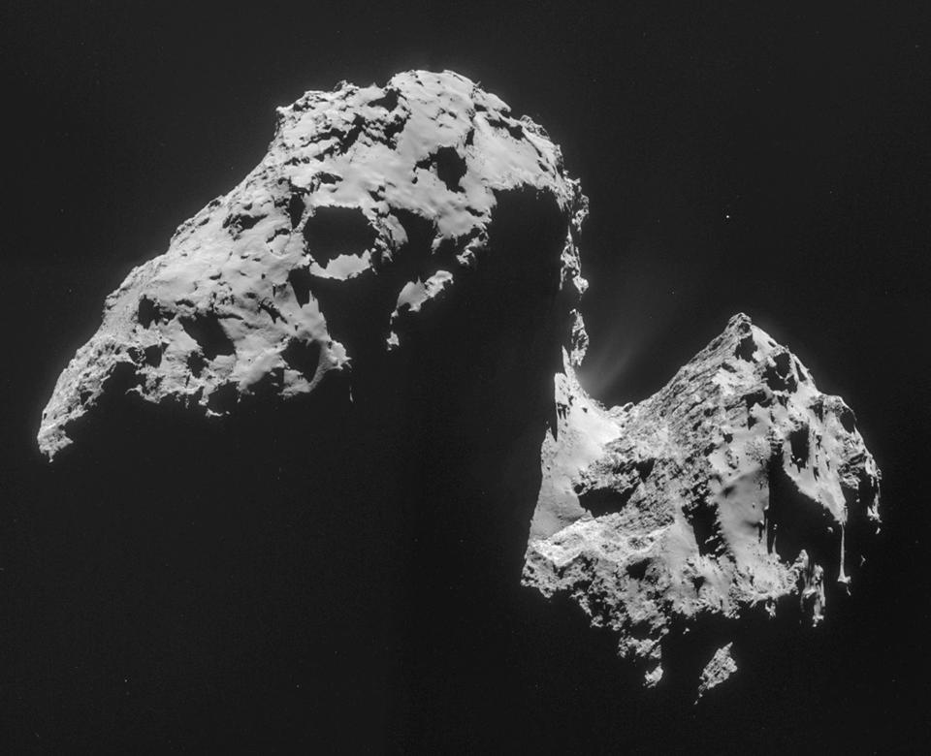<http://news.yahoo.com/mystery-where-earths-water-came-deepens-191158626.html>

*By SETH BORENSTEIN*

The image comprised of four images taken with the navigation camera on Rosetta and released by the European Space Agency ESA on Thursday, Nov. 20, 2014 shows comet 67P/Churyumov-Gerasimenko on Nov. 17, 2014 from a distance of 42 km (26 miles) from the center of the comet. (AP Photo/ESA)

WASHINGTON (AP) — The mystery of where Earth's water came from got murkier last month when some astronomers essentially eliminated one of the chief suspects: comets.

Over the past few months, the European Space Agency's Rosetta space probe closely examined the type of comet that some scientists theorized could have brought water to our planet 4 billion years ago. It found water, but the wrong kind.

It was too heavy. One of the first scientific studies from the Rosetta mission found that the comet's water contains more of a hydrogen isotope called deuterium than water on Earth does.

"The question is who brought this water: Was it comets or was it something else?" asked Kathrin Altwegg of the University of Bern in Switzerland, lead author of a study published in the journal Science. Something else, probably asteroids, Altwegg concluded. But others disagree.

Many scientists have long believed that Earth had water when it first formed, but that it boiled off, so that the water on the planet now had to have come from an outside source.

The findings from Rosetta's mission to the duck-shaped comet 67P/Churyumov-Gerasimenko complicate, not just the question of the origin of Earth's water, but our understanding of comets.

Until now, scientists pretty much sorted comets into two types: near and far. The near ones, sometimes called the Jupiter family, originally come from the Kuiper Belt outside Neptune and Pluto. The far ones hail from the Oort Cloud, which is much farther out.

In 1986, a spacecraft came within about 400 miles of Halley's comet, an Oort Cloud comet, and analyzed its water. It proved to be heavier than Earth's. But three years ago, scientists examined the water in a Kuiper Belt comet, Hartley 2, and it was a perfect match for Earth's, so the comet theory was back, stronger than ever, Altwegg said.

The comet visited by Rosetta is a Kuiper Belt comet, but its water was even heavier than Halley's, Altwegg said. That shows that Kuiper Belt comets aren't as uniform as thought, and it once again complicates the issue of Earth's water. "That probably rules out Kuiper Belt comets from bringing water to Earth," she said.

University of Maryland astronomer Michael A'Hearn, who wasn't part of the research, called the results startling but said they don't eliminate comets altogether. The water could have come from other types of Kuiper Belt comets, he said.

NASA Near Earth Object program manager Donald Yeomans, however, said the study does pretty much rule out comets.

**Editor’s Note: Since the Earth by evolutionary thinking boiled off all of its water in it’s “hot” beginning, it had been theorized that all the water we had came from later collisions with comets. This article adds to the evidence that our water could not have come from comets. Add to that, evidence from the Earth that deep embedded zircons formed in a “cool” primordial Earth inundated with water and you are left with a real possibility that the scriptures are telling the truth when they tell us that the whole creation, including the Earth, were formed out of water and that the water we see today was there from the creation, just as the Bible says it was.**

**The Original Spark of Life on Earth?**

WASHINGTON (AP) — Scientists in a lab used a powerful laser to re-create what might have been the original spark of life on Earth.

The researchers zapped clay and a chemical soup with the laser to simulate the energy of a speeding asteroid smashing into the planet. They ended up creating what can be considered crucial pieces of the building blocks of life.

The findings do not prove that this is how life started on Earth about 4 billion years ago, and some scientists were unimpressed with the results. But the experiment does bolster the long-held theory.

"These findings suggest that the emergence of terrestrial life is not the result of an accident but a direct consequence of the conditions on the primordial Earth and its surroundings," the researchers concluded in the study published Monday in the journal Proceedings of the National Academy of Sciences.

The laser-zapping produced all four chemical bases needed to make RNA, a simpler relative of DNA, the blueprint of life. From these bases, there are many still-mysterious steps that must happen for life to emerge. But this is a potential starting point in that process.

Scientists have been able to make these RNA bases other ways, using chemical mixes and pressure, but this is the first experiment to test the theory that the energy from a space crash could trigger the crucial chemical reaction, said lead author Svatopluk Civis of the Heyrovsky Institute of Physical Chemistry in Prague.

Civis said the scientists used a laser almost 500 feet long that for a fraction of a second zapped the chemical soup with an invisible beam. The power was so intense and concentrated that Civis said that for less than a billionth of a second, it was equivalent to the output of a couple of nuclear power plants. It produced what would be around a billion kilowatts of energy for that sliver of time over a fraction of an inch, generating heat of more than 7,600 degrees Fahrenheit, the researchers said.

Some of the earliest life on Earth seemed to coincide with a period called the Late Heavy Bombardment, when the solar system's asteroid belt was bigger and stray space rocks hit our planet more often, said study co-author David Nesvorny, a planetary scientist at the Southwest Research Institute in Colorado.

At the time, asteroids were bombarding Earth 10 times more frequently than before or after.

Outside experts were divided about the importance of the experiment.

Steve Benner, a prominent biological chemist at the Foundation for Applied Molecular Evolution in Florida, said it is quite relevant because it produced the starting material that would have been around in an early Earth.

But John Sutherland of the MRC Laboratory of Molecular Biology in Cambridge, England, said the amount produced of one base was so small that the results don't seem relevant. Other researchers also downplayed the work.

An alternative theory of early life on Earth says that microbes arrived here from space aboard a comet or an asteroid — a sort of seed theory of life. Civis' work bolsters what would instead be a fire theory of life. It is a theory of both creation and destruction.

For this whole chemical reaction to work, the extreme energy from the asteroid collision would have had to break down molecules into less-complex chemicals, which then could re-form into the more vital combinations. The type of asteroid impact that might have sparked this process also snuffed out the dinosaurs billions of years later, Nesvorny said.

**Editor’s Note: Did asteroids provide water out of an Oort Cloud which has never been observed or even proven to be mathematically and physically possible? Was it asteroid collisions which provided the energy for chemical formations in an atmosphere which the Earth never had? Was it lightning which inexplicably caused the formation of these chemicals in ways which we cannot even duplicate today in the laboratory? Or did none of this happen since our physics won’t allow it and life was “imported” from outer space, but we don’t know how it could have formed there either?**

**None of these are satisfactory explanations scientifically or logically for the formation of organic molecules and life. The complexity of life and the specificity of its building blocks attest to their being specially designed and fabricated by a Creator! We need to see through such “high brow” discussions as the ones above and see that they are missing the obvious answer because they have left God out of the realm of answer choices due to their rebellion against him.**

**Answers in Genesis could sue to get back Tax Incentives**

**ONENEWSNOW - LOUISVILLE, Ky. (January 5, 2015) - A legal storm could be brewing in Kentucky over the state's withdrawal of a tax incentive for a religious-themed Noah's Ark attraction.**

The Christian ministry building the ark, Answers in Genesis, is challenging the state's decision to reject a sales tax rebate that could be worth $18 million.  
   
Kentucky tourism officials in December withdrew preliminary approval for the theme park's tax benefit, saying they could not provide state money to an attraction that would screen hires for religious preference and proselytize to visitors.  
   
But supporters of the project are encouraging the ministry to sue, and a legal expert says they could have success arguing the case in court.  
   
Mike Johnson, an attorney representing Answers in Genesis, said the state is not allowed to treat religious groups differently than other entities seeking tax benefits.



## Answers in Genesis in San Antonio

**Fellowship Bible Church**, (8603 Huebner Rd., San Antonio, TX 78240) will sponsor a creation seminar given by **Bryan Osborne of Answers in Genesis** on **March 22 and 23, 2015**. The schedule and topics to be presented are shown below. For more information call 210-699-6511 or go to the churches’ website at [http://www.fbcsatx.com](http://www.fbcsatx.com/) [**Get Directions**](http://maps.google.com/maps?daddr=8603%20Huebner%20Rd.%20San%20Antonio%20TX%2078240%20US&hl=en)

## Schedule

Bryan Osborne

## Sunday, March 22

## 9:30 a.m. ****Do Animals Evolve? Evolution Defined****

10:45 a.m. **The Relevance of Genesis in Today's World**

6 p.m. **Evolution's Hero: Father Time**

7:30 p.m. **Rocks and Fossils: Testimony of Noah's Flood**

**Monday, March 23**

9:30 a.m. **Dinosaurs and the Bible for Kids (Grades K-6)**

10:45 a.m. **One Blood, One Race (Grades 7-12)**

6 p.m. **Dinosaur Delusion: Dinosaurs, Dragons and the Bible**

7:30 p.m. **Why Won't They Listen? Revealing the Unknown God**

**Irreverent Tweet by Neil deGrasse Tyson** **on Christmas Day**

“On this day long ago, a child was born who, by age 30, would transform the world. Happy Birthday Isaac Newton b. Dec 25, 1642.” Dr. Tyson thought he was being cute, but instead he showed his disdain and lack of respect for Christians everywhere and for the Lord himself. Unfortunately this exemplifies the disdain the secular community has for our God and why so many of them are so committed to keep any mention of Him out of our schools and textbooks.

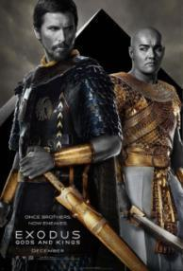**Exodus: Gods and Kings – Movie Review**

The new Exodus movie came out on December 12 with Christian Bale playing Moses. It is biblically inspired and is not the train wreck that Noah was, but it still has its downfalls.

Its timing is probably 150 years off according to biblical and other records. It, like the earlier epic, ”The Ten Commandments” by the legendary Cecille B. DeMIlle took liberties to slightly change and or add story lines to “flesh out” the story.

My objections to this film have to do with its overall attitude toward God. It depicts Moses as an anarchist and wager of guerilla warfare, rather than as a man led by God’s will. It paints Moses with a continuingly hostile and disrespectful attitude toward God, whereas in the **Ten Commandments**, Moses attitude toward God became more and more respectful as the movie went on.

All of the plagues and the parting of the Red Sea are at least hinted at being attributable to naturalistic causes and may have been chance occurrences which had nothing to do with God. Only the visit by the Death Angel is clearly the work of God.

God is portrayed as a “petulant child” in this movie by both his bratty actions and speech. To back up this persona, when seen, God is shown as a bald 10 year old child. This is a highly disrespectful painting of the Almighty.

Finally, Moses’ interactions with God are portrayed in such a way as to let the viewer decide whether Moses actually ever had interactions with God, or he was just a demented crazy man who thought he did and led hundreds of thousands via his demented visions.

On the whole I would recommend the Original **“Ten Commandments”** over this new movie. The effects are almost as good, it is more biblical than Exodus and above all, **”The Ten Commandments”** story and morals are much more in line with the biblical account than the skeptical rewrite of **Exodus: Gods and Kings.**

For two more reviews on this movie go the Answers in Genesis website and search for “Exodus.”

**Prayer Needs and Praises!**

**John Morris**is recovering from a stroke as he continues a long term battle with muscular dystrophy. John is the long time President of the Institute for Creation Research, a PhD Geological Engineer, and one of the most prominent writers, researchers, and leaders in creation science. Pray for miraculous healing! Dr. Morris is also giving up his post as President of ICR due to his health and we ask for prayer for the leadership ICR as they go forward.

**Sue Stepanek** is battling cancer. Surgery went well but recovery is slow due to her also having Celiac Disease which was discovered only after surgery. Sue is the wife of Richard Stepanek who speaks for Alpha Omega Institute. Pray for complete recovery.

**SABBSA and SABA.** Pray that SABBSA is given a place in this year’s Unapologetics Conference with the San Antonio Baptist association. Talks have been ongoing for 18 months on this and it is still not resolved.

Answers in genesis and their Ark Encounter project have come under intense political attack and the state of Kentucky has now rescinded their rights to tax incentives provided to all tourist attractions such as them. Please pray that God will restore these tax incentives to Ark Encounter.

**Two exciting creation seminars starting in February 2015**

**SABBSA** has been asked to give two full days of presentations at the **Castle Hills First Baptist Church School on February 5th and 6th of 2015.** We are currently discussing and praying about which presentations which will go to elementary, middle school and high school groups. We will publish the schedule of these presentations as these arrangements are finalized. We thank Castle Hills for this opportunity and their trust in us to spread God’s truth to our young!

**Biblical Creation Seminar at Cibolo Valley Baptist Church**

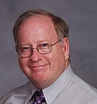**SABBSA President Scott Lane** will conduct a 12 week seminar on **Biblical Creationism at Cibolo Valley Baptist Church, starting on Sunday February 8, 2015 at 4:30 pm** and continuing each Sunday afternoon thereafter through February, March and April. This seminar makes it clear science and the Bible support one another as we would suspect since God spoke both into existence! Below are the topics we will cover this spring.

February 8 – **What** **If God Wrote the Bible? – Part I**

February 15 – **What If God Wrote the Bible? – Part II**

February 22 – **The Major Theories of Creation**

March 1 – **Darwin and Radiometric Dating**

March 8 – **Fossils, Physics and Genetics – Our World Specially Crafted by God!**

March 15 – **Young Earth Evidences**

March 22 - **Biology** **and Intelligent Design: Animals that Defy Evolution!**

March 29 - **Biology and Missing Links: Lucy Unveiled**

April 5 – **God, Man and Dinosaurs**

April 12 - **Creation and the Courts: The DeFaithing of America**

April 19 – Class pick of eight remaining creation presentations

April 26 – Class pick of seven remaining creation presentations

******New ICR video series to be shown at FEAST!

This year our FEAST Science Workshops will feature the new 12-part series from the Institute for Creation Research entitled “Unlocking the Mysteries of Genesis.” Viewing this series, you’ll walk away with a fresh understanding of the sometimes difficult-to-comprehend issues surrounding creation. Our dynamic host will lead you through discoveries of truth in awe-inspiring locations around the country. We will visit gardens and nature sites throughout Texas, the Grand Canyon, Dinosaur National Monument in Utah, and the Matanuska Glacier in Alaska.

From discussions on dinosaurs to the Ice Age, the series covers the origin of the universe, the origin of man, design, fossils, Noah’s Flood, the age of the earth, ancient civilizations, and more. We invite you to spend fourth Mondays with us at 6:30 pm for this series of videos with two episodes shown each night along with expert commentary and question and answer sessions from the staff of the **San Antonio Bible Based Science Association.**

Our first two sessions this fall were attended by groups of more than 50 people with a host of young kids in each seminar. We are viewing two episodes each night with very engaging question, answer, and discussion sessions following both videos.

Below is the list of topics to be covered this spring:

**January 26, 2015 Noah’s Flood.**  **Age of Earth.**

Young Children’s topic: **"How do you feel?"** We'll explore a touchy subject: the  
tactile world.

**February 23, 2015 Dinosaurs.** **The Ice Age.**

Young Children’s topic: **"Fossils: Can you dig 'em?"** The annual chocolate fossil blow  
out.

**March 23, 2015 Ancient Civilization. Origin of the Universe.**

Young Children’s topic: **"Wind beneath my wings"** Demonstrating the power of the air.

**April 27, 2015 Uniqueness of Earth. The Big Picture**

Young Children’s topic: **"The strength within"** Unleashing the power within common  
substances.

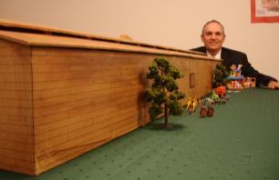**Noah’s Ark Presentation at Huisache Ave. Baptist**

Dr. Michael Todd, will be speaking on Sunday, January 18, 2015 – 6:30pm at Huisache Ave. Baptist Church (1339 W. Huisache Ave.) on the topic of Noah’s Ark. Dr. Todd will give a multimedia presentation with a 7-foot scale model of Noah’s Ark on display.

For more information call the church at 210 732-1276. If you would like to preview Dr. Todd’s presentation go to you tube at <https://www.youtube.com/watch?v=9ANB9fXGAtQ>

**Humor Corner**

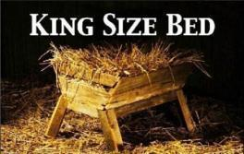**The first King Sized Bed**

**Around Texas**

**Houston:**   
The **Greater Houston Creation Association** (**GHCA**) meets the first Thursday of each month. They meet at Houston's First Baptist Church at 7 pm, in Room 258. After the presentation, there will be refreshments, fellowship and creation science materials for all to enjoy. For more information go to [www.ghcaonline.com](http://r20.rs6.net/tn.jsp?llr=bztaencab&et=1103662222545&s=545&e=001xF-6WOYzM5Yyre44Ea_qUjH5EOT_fFIGjrfpfa5h-rD53IlUVbz3Vc0Dp47_VEwW3iQQ6F1b6K0EtKc_vUxYKpzN_8V2upXFbsOScvUeD92nJdUTjDIFeg==).

**Glen Rose:**   
Dr. Carl Baugh gives a “***Director’s Lecture Series***” on the first Saturday of each month at the Creation Evidences Museum just outside Glen Rose, TX. The new and improved museum is also a great and beneficial way to spend any day. Presentations are at 11 am and 2 pm. For more information go to [www.creationevidence.org](http://www.creationevidence.org)

**Dallas-Ft Worth:**   
The Metroplex Institute of Origin Science (MIOS) meets at the Dr. Pepper Starcenter, 12700 N. Stemmons Fwy, Farmers Branch, TX, usually at 7:30 pm of the first Tuesday of each month.

**Lubbock Area (Crosbyton):**   
All year: Consider a visit to the Mt. Blanco Fossil Museum, directed by Joe Taylor. The Museum is definitely worth the visit if you live near or are traveling through the Panhandle near Lubbock. If you call ahead and time permitting, Joe has been known to give personal tours, especially to groups. For more information, visit [http://www.mtblanco.com/](http://r20.rs6.net/tn.jsp?llr=bztaencab&et=1103662222545&s=545&e=001xF-6WOYzM5bqqt6T1G_CwJWJosrOSIhLAagtnP0Z504J-gEROEBe22S3gq720x6ofjFVqK-AfJcsjrsuQyRtoepYiAQVVUFC-cF56fLwwBJ0SQ-44KlLmw==).

**Greater San Antonio area:**

Listen to **Answers with Ken Ham** online at the address below. (No nearby station for this broadcast). <http://www.answersingenesis.org/media/audio/answers-daily>

To hear program from the **Institute for Creation Research**, listen online at this address. <http://www.icr.org/radio/>

Also, tune in KHCB FM 88.5 (San Marcos) or KKER FM 88.7 (Kerrville) for **Back to Genesis** at 8:57 AM Mon-Fri, then **Science, Scripture and Salvation** at 1:30 AM, 8:00 AM and 4:30 PM on Saturdays.

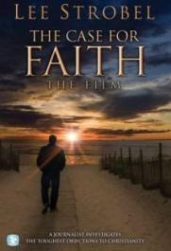**Last Month at SABBSA**

**The Case for Faith**

In this video journalist **Lee Strobel** investigates two of the most emotional objections to Christianity. Barriers to faith confronted by believers and skeptics alike: Why is Jesus the only way to God? And, how could a loving God exist if there is evil and suffering in the world?

Skeptics of Christianity are everywhere, boldly asking tough questions in order to disprove the faith. Doubt no more! Author Lee Strobel, a journalist, investigated the toughest objections to Christianity and found solid answers. Whatever intellectual or emotional objections one has to the Christian faith are directly refuted by Strobel's honest and thorough discoveries.

Our viewers found this video to be a sound evangelical tool with no problems for the young earth creationist. It also evoked an inspired debate within our own ranks around the questions of Calvinist vs. the Armenian views of eternal security. We recommend this video as a powerful evangelical tool.

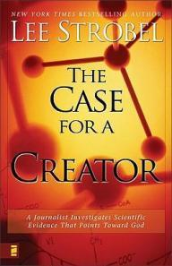**Next SABBSA Meeting:**

**Tuesday, January 13, 2015 at 7 pm**

**Coming to SABBSA in January**

**The Case for a Creator**

**Has Science Discovered God?**

When Lee Strobel was a high school freshman, science convinced him that God didn’t exist. Since then, however, incredible scientific discoveries have not only helped restore Lee’s faith, but have strengthened it.

Lee is not alone. More and more scientists, confronted with startling, cutting-edge evidence from many areas of research, no longer believe the universe just “happened” or that life arose by mere chance. Behind a universe of staggering complexity, they are seeing signs of a Master Designer.

Are your science textbooks still telling you the same “facts” that Lee’s did years ago? Prepare to be astonished by what some of today’s most respected experts have to say about:

The birth of the universe  
Darwinism and the origin of life  
The astounding fine-tuning of the cosmos  
Amazing molecular machines and DNA research

Weigh the evidence for yourself. Then consider this question: Could it be that the universe looks designed … because it is?

Please join us in January for this Christian apologetics classic. As always, we will meet at the Jim’s Restaurant at the corner of San Pedro and Ramsey at 7 pm. Please join us for good food, fellowship and impactful Christian apologetic teaching.