President - Scott Lane 599-7240 Vice President – Capt. Harry Jackson, USAF (Ret.)
Secretary – Clarence Johnson Treasurer – Carl Williams, M.D.
[website – www.sabbsa.org ] [P.O. Box 34478, San Antonio, TX 78265]

We hope you are beginning a wonderful set of summer months for you and your family. We in San Antonio have recently experienced a lot of much needed rain which has forestalled the summer heat a bit. We thank God for this answer to prayer.
This month’s Communiqué from SABBSA has an article on how a lab has created an artificial life form using both the traditional four nucleotides plus an additional two artificial nucleotides. This article will explore the ramifications of this work.
We also have an article on new evidence that antibiotic resistance is not and never has been evolved by nature, but is a natural outgrowth of the preprogramming of the DNA code which God set up for us from the creation.
Finally, we have the results of a new AP poll showing that our creation message is penetrating through the best of efforts of academia, the media and public schools to silence the truth about God’s creation.
Of course we have a listing of all of the creation activities available to you in South Texas. We hope you find this newsletter informational for you.

Scientists Create 1st Living Organism from Artificial DNA
HealthDay May 7, 2014
By Alan Mozes, HealthDay Reporter

Move over, Frankenstein! Your 21st-century counterpart has just been announced.
In true sci-fi fashion, a team of researchers from The Scripps Research Institute (TSRI) in La Jolla, Calif., has created a brand-new bacteria based on a genetic structure found nowhere on Earth.
According to lead researcher Floyd Romesberg, the feat involved artificially engineering a unique combination of DNA material -- a combination not found in any living creature -- and then successfully inserting it into a living cell that usually contains only natural combinations of DNA.
"Life on Earth in all its diversity is encoded by only two pairs of DNA bases, A-T and C-G," Romesberg explained in an institute news release. "And what we've made is an organism that stably contains those two plus a third, unnatural pair of bases."
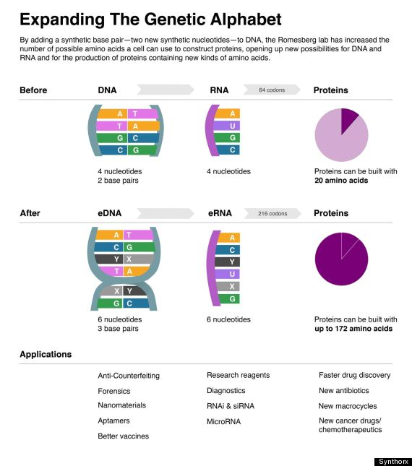
"This shows that other solutions to storing [genetic] information are possible," he added, "and, of course, takes us closer to an expanded-DNA biology that will have many exciting applications -- from new medicines to new kinds of nanotechnology."
Romesberg and his colleagues discuss their handiwork -- funded in part by the U.S. National Institutes of Health -- in the May 7 online edition of Nature.
The product of more than 15 years of work, the current effort builds on a proof-of-concept study conducted in 2008. At that time, investigators had shown that hooking up natural and unnatural pairings of DNA was possible in a test-tube setting.
The next challenge was to replicate the process inside a living cell. The cell chosen by the TSRI team was the common E. coli bacterium, and into it they inserted what they considered to be the best unnatural DNA pairing they could construct: a combination of two molecules called "d5SICS" and "dNaM".
After leaping through a series of highly complex technical problems, the study authors finally managed to pull off their goal: the fashioning on a half-synthetic organism that could actually replicate its unnatural self as long as scientists continuously supplied it with the necessary molecular material.
Romesberg said that, in principle, his team's high-concept work has a very practical purpose: to gain a "greater power than ever" to fashion new treatments by harnessing the power of genetics.

Editors Note: Note that the use of two new nucleotides was shown to be possible, but not feasible in our natural environment. The cell was not viable because it had to be continually fed with unnatural agents or it could not reproduce itself since those new agents are not available in the natural environment here on Earth. What they did show was another good example of the how just making DNA is not enough. There must be a fully functional cell produced around it at the same time to sustain and use the DNA.
The researchers work is impressive, but only shows that reader RNA, much like a computer will make copies (replicate) what it finds programmed into it whether that is good stuff or not. This work tells us nothing about where we came from as it misses answering the big problem of a functional cell’s formation which must happen simultaneously with the formation of DNA for life to be possible.
The underlying truth to all this is that it took 15 years of directed experimentation and an inordinate amount of design by human intelligence to achieve this feat. It did not occur by chance, nor could it in our environment. Seen from a correct perspective, it is excellent evidence that life and its supporting environment have been carefully crafted and designed by a Creator!

Antibiotic Resistance
The Lechuguilla Cave in New Mexico is a network of chambers stretching 1,600 feet underground. The bacteria that grow on the walls of its most remote recesses have been living in complete isolation for more than four million years.
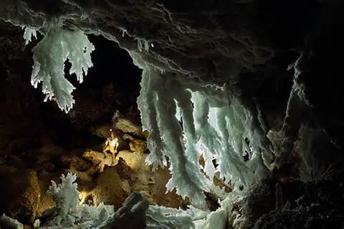
In 2010, Gerry Wright, a microbiologist at McMaster University in Ontario, ran an experiment on those long-lost bacteria. He and his colleagues doused them with antibiotics, the drugs that doctors have used for the past 70 years to wipe out bacterial infections.
But many of the Lechuguilla bacteria would not die.
“Most of them were resistant to something,” said Dr. Wright. Some strains, he and his colleagues found, could resist 14 commercially available antibiotics.
Dr. Wright’s discovery didn’t fit the conventional story of antibiotics. Antibiotics were introduced in the mid-1900s. Each time a new drug was introduced, it would take years before bacteria that could resist it became common.
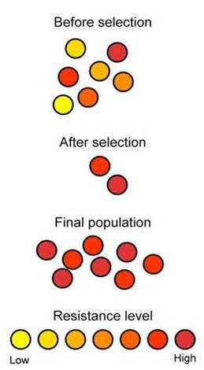
In the decades since, this trend has turned into a crisis. Last week, the World Health Organization reported that antibiotic resistance is now a major threat to public health across the entire planet. “We will soon hit the wall,” warned Joseph Nesme, a microbiologist at the University of Lyon in France.
At first, the antibiotics crisis seemed like a simple story of evolutionary cause and effect. Whenever bacteria reproduce, there’s a tiny chance that a mutation will emerge that lets them resist an antibiotic. When we take that antibiotic, the mutant microbes can thrive while susceptible bacteria die.
If that were all there was to the story, the Lechuguilla Cave bacteria should have been easy targets. Cut off from the world, they never had a chance to evolve resistance to our drugs.
But Dr. Wright discovered that they were already prepared. They had many genes that allowed them to survive what should have been a fatal dose of antibiotics.
Their resistance hinted that antibiotic-resistance genes were not just the product of modern medicine, but an ancient part of nature.
Now a new study from Mr. Nesme and his colleagues reveals just how widespread resistance is.
To carry out their study, Mr. Nesme and his colleagues took advantage of the fact that many teams of scientists are gathering huge amounts of DNA from all over the world. They’ve cataloged millions of genes, and made them available in online databases.
Mr. Nesme and his colleagues searched the databases from 71 of those places — everywhere from Antarctic ice to the bottom of the ocean. They looked for genes that were similar to the ones that disease-causing bacteria use to resist antibiotics.
As the authors report in the journal Current Biology, they hit the jackpot. “We find them in all environments,” said Mr. Nesme.
Dr. Wright, who was not involved in the research, said that Mr. Nesme’s study confirms the work that he and his colleagues have been doing. “This paper reinforces that resistance is everywhere,” he said.
Scientists are puzzled about why resistance genes should be so old and so widespread. If the genes didn’t evolve recently to fight against modern medicine, what are they doing in other bacteria?
They’re probably doing a lot of things. Bacteria make their own antibiotics, for example, which they sometimes use to fend off competitors. Some of their competitors have evolved ways to resist those deadly molecules.
In addition, some resistance genes can be found in antibiotic-producing bacteria themselves. These bacteria can defend against their own poisons. “Otherwise, they make antibiotics once and commit suicide,” said Dr. Wright.
But a number of studies suggest that bacteria use resistance genes for jobs that have nothing to do with antibiotics.
Last week, for example, Dr. Wright and his colleagues published a study they had conducted on bacteria that live in soil. They found a gene in these bacteria that provides resistance to an antibiotic called rifamycin.
Or rather, it would provide resistance if the bacteria actually used the gene. But when Dr. Wright and his colleagues exposed the bacteria to rifamycin, the gene remained silent and the bacteria died.
Dr. Wright suspects that the soil bacteria use the rifamycin-resistance gene to perform a different job. But what that job is, he has no idea.
The global supply of resistance genes that scientists are uncovering appears to be fueling the antibiotics crisis. That’s because disease-causing bacteria can pick up resistance genes from other species and use them to fight our drugs.
Resistance genes can move between different species of microbes in many ways. Viruses, for example, can pick up DNA from one microbial host and then ferry it to another.
In some cases, disease-causing bacteria are simply borrowing genes that other bacteria were already using to resist antibiotics in nature. In the 1980s, for example, doctors saw an abrupt rise of bacteria resistant to the antibiotic vancomycin. Dr. Wright and his colleagues later discovered the source of their genes. They came from the very bacteria that make vancomycin in nature.
In other cases, Dr. Wright suspects, disease-causing bacteria pick up genes that other microbes used for different jobs. It just so happens that those genes can also make bacteria able to withstand to a particular antibiotic.
“All of a sudden you get something we recognize as resistance,” said Dr. Wright.
It’s sobering to realize that we’re up against a planet’s worth of resistance genes. But understanding our enemy is better than ignorance. Dr. Wright thinks that new antibiotics should be tested not just against the bacteria that live inside of us and make us sick. They should also be tested on bacteria living in the soil or the ocean. Scientists would discover the resistance genes that will someday threaten the usefulness of a new drug.
“It would be an early warning system, so you could at least be on the lookout,” he said.
Editor’s Note: This is excellent evidence that bacterial immunity to antibiotics is an inheritance of already formed genes and not evidence of evolved immunity. This example along with the Franklin Expedition shows that variation and selection can bring about strains of bacteria with immunity to antibiotics, but only using immune information already preprogrammed into their DNA. No new information is created. No evolution of a new species is occurring.

New Poll Reveals Many Americans Express Doubt Over Global Warming, Evolution, Big Bang

| by JENNIFER AGIESTA and SETH BORENSTEIN 04/22/2014
WASHINGTON (AP) — Few Americans question that smoking causes cancer. But they express bigger doubts as concepts that scientists consider to be truths get further from our own experiences and the present time, an Associated Press-GfK poll found.
Americans have more skepticism than confidence in global warming, the age of the Earth and evolution and have the most trouble believing a Big Bang created the universe 13.8 billion years ago.
Rather than quizzing scientific knowledge, the survey asked people to rate their confidence in several statements about science and medicine.
On some, there's broad acceptance. Just 4 percent doubt that smoking causes cancer, 6 percent question whether mental illness is a medical condition that affects the brain and 8 percent are skeptical there's a genetic code inside our cells. More — 15 percent — have doubts about the safety and efficacy of childhood vaccines.
About 4 in 10 say they are not too confident or outright disbelieve that the earth is warming, mostly a result of man-made heat-trapping gases, that the Earth is 4.5 billion years old or that life on Earth evolved through a process of natural selection, though most were at least somewhat confident in each of those concepts. But a narrow majority — 51 percent — questions the Big Bang theory.
Those results depress and upset some of America's top scientists, including several Nobel Prize winners, who vouched for the science in the statements tested, calling them settled scientific facts.
"Science ignorance is pervasive in our society, and these attitudes are reinforced when some of our leaders are openly antagonistic to established facts," said 2013 Nobel Prize in medicine winner Randy Schekman of the University of California, Berkeley.

The poll highlights "the iron triangle of science, religion and politics," said Anthony Leiserowitz, director of the Yale Project on Climate Change Communication. And scientists know they've got the shakiest leg in the triangle.
To the public "most often values and beliefs trump science" when they conflict, said Alan Leshner, chief executive of the world's largest scientific society, the American Association for the Advancement of Science.
Political values were closely tied to views on science in the poll, with Democrats more apt than Republicans to express confidence in evolution, the Big Bang, the age of the Earth and climate change. Religious values are similarly important.
Confidence in evolution, the Big Bang, the age of the Earth and climate change decline sharply as faith in a supreme being rises, according to the poll. Likewise, those who regularly attend religious services or are evangelical Christians express much greater doubts about scientific concepts they may see as contradictory to their faith.
"When you are putting up facts against faith, facts can't argue against faith," said 2012 Nobel Prize winning biochemistry professor Robert Lefkowitz of Duke University. "It makes sense now that science would have made no headway because faith is untestable."
But evolution, the age of the Earth and the Big Bang are all compatible with God, except to Bible literalists, said Francisco Ayala, a former priest and professor of biology, philosophy and logic at the University of California, Irvine. And Darrel Falk, a biology professor at Point Loma Nazarene University and an evangelical Christian, agreed, adding: "The story of the cosmos and the Big Bang of creation is not inconsistent with the message of Genesis 1, and there is much profound biblical scholarship to demonstrate this."
Beyond religious belief, views on science may be tied to what we see with our own eyes. The closer an issue is to our bodies and the less complicated, the easier it is for people to believe, said John Staudenmaier, a Jesuit priest and historian of technology at the University of Detroit Mercy.
Marsha Brooks, a 59-year-old nanny who lives in Washington, D.C., said she's certain smoking causes cancer because she saw her mother, aunts and uncles, all smokers, die of cancer. But when it comes to the universe beginning with a Big Bang or the Earth being about 4.5 billion years old, she has doubts. She explained: "It could be a lack of knowledge. It seems so far" away.
Jorge Delarosa, a 39-year-old architect from Bridgewater, N.J., pointed to a warm 2012 without a winter and said, "I feel the change. There must be a reason." But when it came to Earth's beginnings 4.5 billion years ago, he has doubts simply because "I wasn't there."
Experience and faith aren't the only things affecting people's views on science. Duke University's Lefkowitz sees "the force of concerted campaigns to discredit scientific fact" as a more striking factor, citing significant interest groups — political, business and religious — campaigning against scientific truths on vaccines, climate change and evolution.
Yale's Leiserowitz agreed but noted sometimes science wins out even against well-financed and loud opposition, as with smoking.
Widespread belief that smoking causes cancer "has come about because of very public, very focused public health campaigns," AAAS's Leshner said. A former acting director of the National Institute of Mental Health, Leshner said he was encouraged by the public's acceptance that mental illness is a brain disease, something few believed 25 years ago, before just such a campaign.
That gives Leiserowitz hope for a greater public acceptance of climate change. But he fears it may be too late to do anything about it.
The AP-GfK Poll was conducted March 20-24, 2014, using KnowledgePanel, GfK's probability-based online panel designed to be representative of the U.S. population. It involved online interviews with 1,012 adults and has a margin of sampling error of plus or minus 3.4 percentage points for all respondents.
Respondents were first selected randomly using phone or mail survey methods and were later interviewed online. People selected for Knowledge Panel who didn't otherwise have access to the Internet were provided with the ability to access the Internet at no cost to them.
Editor’s Note: At a recent presentation Dave Nutting and I were posed a frequently asked question about whether our efforts in the field of apologetics and creation science are winning or losing? My response was that there are two fronts in this war. One is in the area of academia and our schools. In America the public schools and most universities are firmly controlled by evolutionists and they are doing all they can to quash our message.
However, in the field of public opinion, we are holding steady at a majority of Americans who believe they were created by God and doubt evolution and the Big Bang. Such contradictory beliefs to what is being taught by our schools and media show that our message is getting through.
But, it also shows the inherent weakness in the evolutionary premise. Those who believe they were created are really being empirical scientists. They are seeing all of the beauty and designs of nature around them and making a simple evaluation that there must be a Creator and they distrust others who would deny this common sense evaluation. This conclusion of man’s intellect was foretold by God in his word in Romans 1:20 where God through Paul said “For the invisible things of him from the creation of the world are clearly seen, being understood by the things that are made, even his eternal power and Godhead; so that they are without excuse…”

June 7, 2014
SABBSA and AOI in the Rio Grande Valley
On Saturday, June 7 SABBSA will have the honor of collaborating with the
Alpha Omega Institute (AOI) at the 3rd Annual Rio Grande Valley Home School Conference which will be held at First Church of the Nazarene, 2001 N. 7th Street, Harlingen, TX 78550. Doors open at 8 am.
Scott Lane will present at 2 pm on the topic of "The Theories of Creation." All day long SABBSA board members will staff a booth at the convention providing valley home school families with AOI's excellent materials.
August 30, 2014, 10:30 am to 12:30 pm
How I Know Ministries
On Saturday, August 30 creation evangelists Mario and Danielle Lopez will present their testimonies and creation evidences at Living Way Church's Family Life Center. Their multimedia presentation includes some excellent film clips on various creation science topics and their testimonies reveal the journey of how one came to faith and another found the designs of the Creator!
Their goal is to fulfill the commandment in scripture that we are "always to be ready with an answer" for the reasons you have the hope we have in Christ! Do you know why you believe what you believe? This presentation examines what we say we believe and why our culture and Christians hold the beliefs each adhere to.

Humor Corner
BROTHEL SUES LOCAL CHURCH OVER LIGHTNING STRIKE
What an interesting turn of events in Mount Vernon, Texas...
Diamond D's brothel began construction on an expansion of their building to increase their ever-growing business. In response, the local Baptist church started a campaign to stymie the business from expanding -- with morning, afternoon, and evening prayer sessions at their church.
Work on Diamond D's progressed right up until the week before the grand re-opening when lightning struck the brothel and burned it to the ground!
After the cat-house was burned to the ground by the lightning strike, the church folks were rather smug in their outlook, bragging about "the power of prayer."
But late last week 'Big Jugs' Jill Diamond, the owner/madam, sued the church, the preacher and the entire congregation on the grounds that the church..."was ultimately responsible for the demise of her building and her business -- either through direct or indirect divine actions or means."
In its reply to the court, the church vehemently and voraciously denied any and all responsibility or any connection to the building's demise.
The crusty old judge read through the plaintiff's complaint and the defendant's reply, and at the opening hearing he commented, "I'm not sure how in the heck I'm going to decide this case, but it appears from the paperwork, that we now have a whorehouse owner who staunchly believes in the power of prayer, and an entire church congregation that thinks it's all a bunch of male bovine excrement."

Around Texas

Houston:
The Greater Houston Creation Association (GHCA) meets the first Thursday of each month. They meet at Houston's First Baptist Church at 7 pm, in Room 258. After the presentation, there will be refreshments, fellowship and creation science materials for all to enjoy. For more information go to www.ghcaonline.com.
Glen Rose:
Dr. Carl Baugh gives a “Director’s Lecture Series” on the first Saturday of each month at the Creation Evidences Museum just outside Glen Rose, TX. The new and improved museum is also a great and beneficial way to spend any day. Presentations are at 11 am and 2 pm. For more information go to www.creationevidence.org

Dallas-Ft Worth:
The Metroplex Institute of Origin Science (MIOS) meets at the Dr. Pepper Starcenter, 12700 N. Stemmons Fwy, Farmers Branch, TX, usually at 7:30 pm of the first Tuesday of each month. Dr. Vernon Cupps of the ICR research team presents on June 3, 2014, on the topic
“Isochrons: Good Mathematics Gone Astray”
Lubbock Area (Crosbyton):
All year: Consider a visit to the Mt. Blanco Fossil Museum, directed by Joe Taylor. The Museum is definitely worth the visit if you live near or are traveling through the Panhandle near Lubbock. If you call ahead and time permitting, Joe has been known to give personal tours, especially to groups. For more information, visit http://www.mtblanco.com/.

Greater San Antonio area:
Listen to Answers with Ken Ham online at the address below. (No nearby station for this broadcast). http://www.answersingenesis.org/media/audio/answers-daily
To hear program from the Institute for Creation Research, listen online at this address. http://www.icr.org/radio/

Also, tune in KHCB FM 88.5 (San Marcos) or KKER FM 88.7 (Kerrville) for Back to Genesis at 8:57 AM Mon-Fri, then Science, Scripture and Salvation at 1:30 AM, 8:00 AM and 4:30 PM on Saturdays.

Last Month at SABBSA
The Best and Worst Arguments against Evolution
At our May meeting we had a vigorous discussion evaluating a list of the best arguments and evidences against the theory of evolution.
We agreed that current evidence that almost the entire human genome is functional is disastrous for the theory of evolution. Among a long list of other good evidences for God's creation and against purposeless evolution were: design features in all living things; DNA evidence which shows we all came from one primordial man and one primordial woman; evolution seems to violate the First and Second Laws of Thermodynamics and the Law of Biogenesis to name just a few of the wealth of evidences discussed.
Along the way we explored how some arguments used by Christians and anti-evolutionists are sometimes not the best. While many arguments have a good basis in fact, they may be hard for the general public to understand or be easily confused by an evolutionary debater so we urged caution in the use of such arguments.

Next SABBSA Meeting:
Tuesday, June 10, 2014, at 7 pm
Coming to SABBSA in June
Evidence for Creation Seminar, Part I
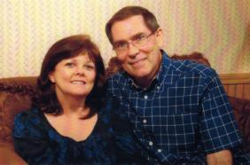
Beginning in June we will start the three part "Evidence for Creation Seminar” by creationist John Heffner (pictured here with his wife).
John is a career mathematician and committed Christian. He is currently head of the math department at Kilgore High School. He teaches Trigonometry and Pre-Calculus. John also serves on the adjunct math faculty at Kilgore College. John participates in numerous research trips and excavations annually. He has presented hundreds of seminars in churches and schools explaining scientific evidences in light of Biblical teaching. He has appeared on several international TV broadcasts discussing creation.
For more on John’s ministry go to http://www.fbclibertycity.com/heffners
Session 1 includes such topics as: "Science plays catch up with the Bible"; "The 6 days of creation"; "Giant animals of the pre-flood world"; and "Human population statistics"
Please join us on June 10 for this thought provoking program, good food and warm Christian fellowship!

